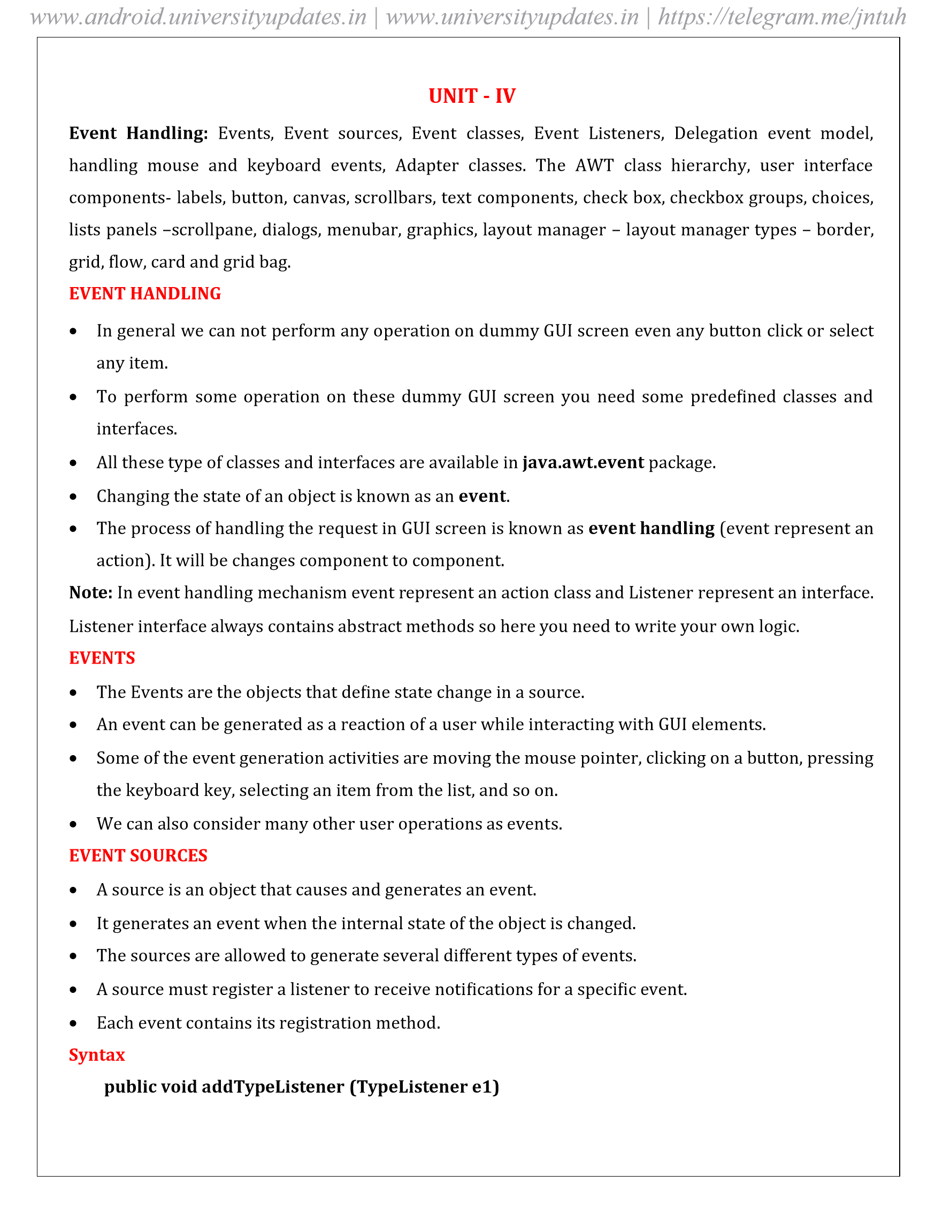
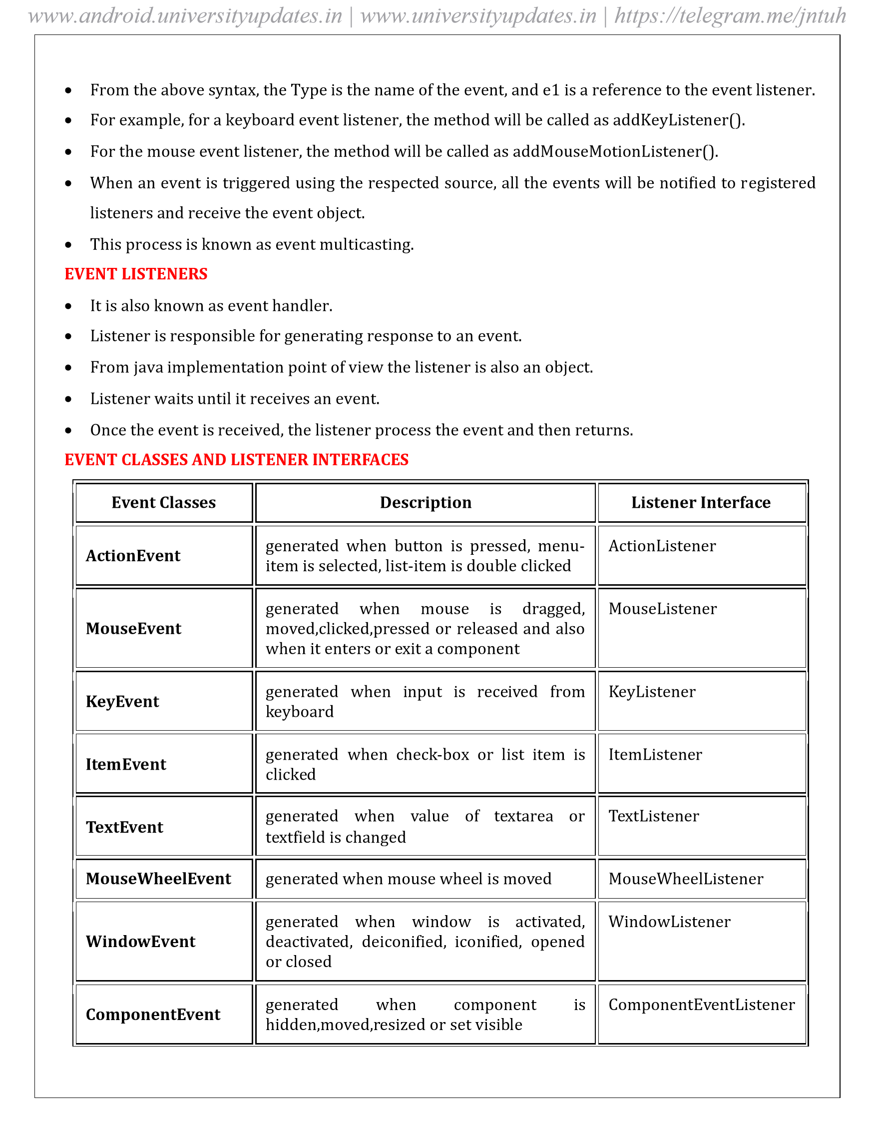
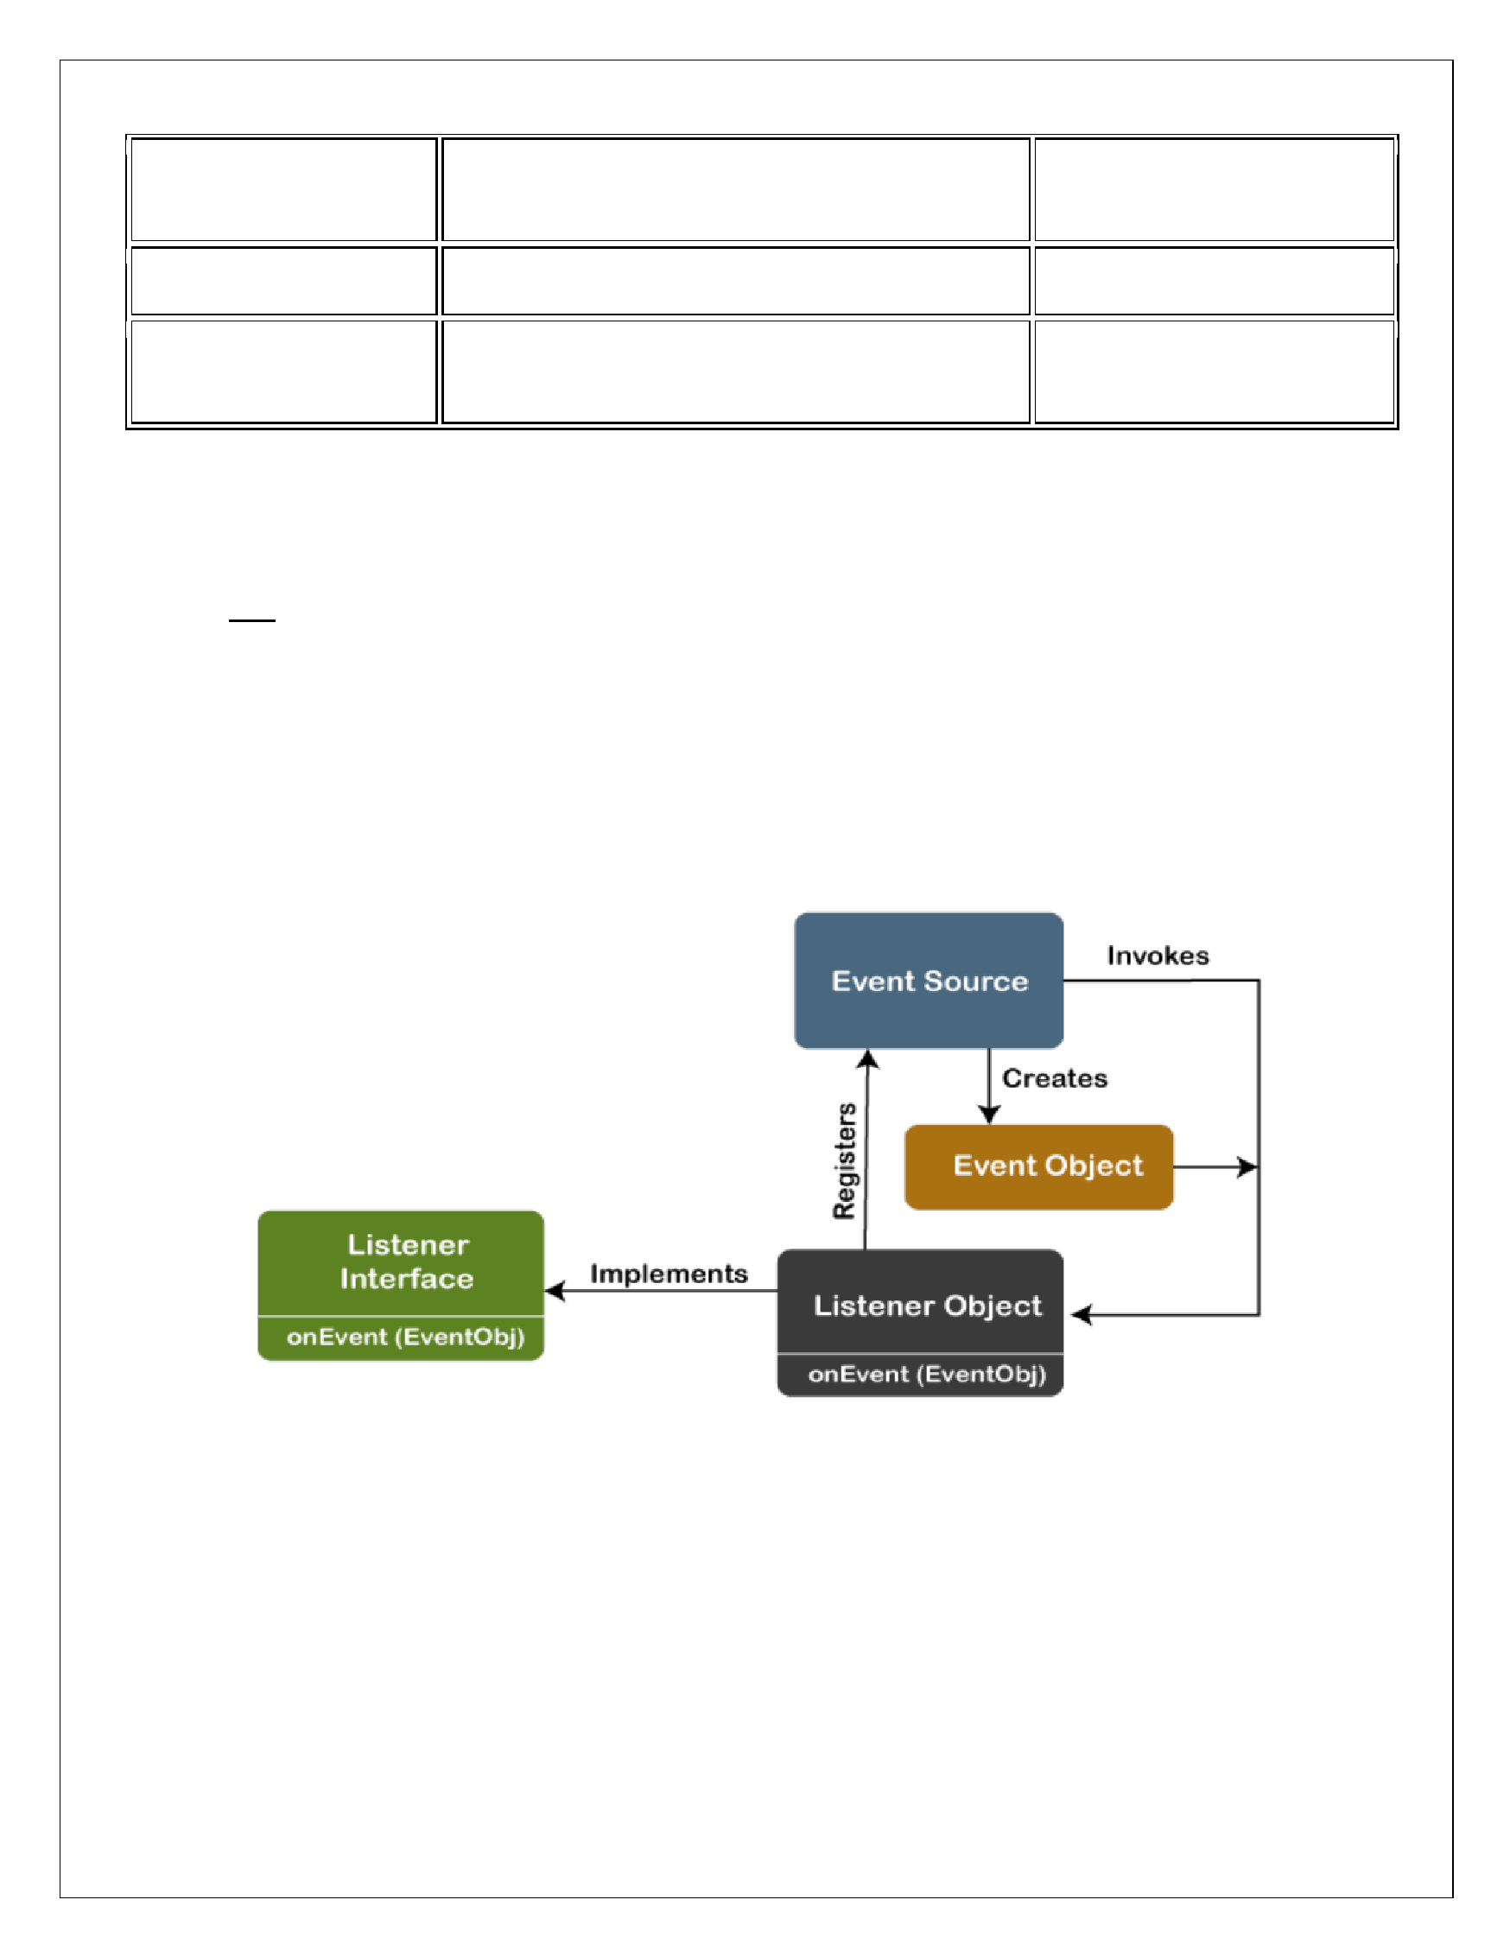
ContainerE
vent

gener
ated
when
component
is
added
or
re
mov
ed from container

ContainerListener

AdjustmentE
vent

gener
ated wh
en scr
oll bar is manipulated

AdjustmentListene
r

F
ocusE
v
ent

gener
ated
w
hen
co
mponent
g
ains
or
los
es
k
eyboard f
ocu
s

F
ocusListener

DELEGA
TION EVENT MODEL IN J
A
V
A

•

The Delegation Event model is deined to handle e
vent
s in GUI
prog
ramming languages.
•

The GUI stands
for
G
raphical
User
I
nterface,

w
here
a
user
graphically/visually
interacts
with

the
sys
tem.

•

The
GUI
p
rogr
amming
is
inherently
event
-
driven;
whenever
a
user
in
itiates
an
activity
such
as
a

mou
se a
ctivity, clicks, scro
lling, etc., each is known as a
n
event that is mapped to a co
d
e to respond

to functionality to the user. This is known as e
v
ent handling
.
The below image demonstrates the event proc
e
ssing.

•

In this model, a source generates
an ev
ent and for
wards it to one or more
l
isteners.

•

The listener waits u
nt
il it
r
eceive
s an ev
ent. Once it receive
s the event, it is proces
sed by the list
ener

and returns it.

www.android.universityupdates.in | www.universityupdates.in | https://telegram.me/jntuh

REGIS
TRA
TION METHODS

F
or registering the com
p
onent with the Listener
, man
y cl
asses
provide the r
egistration methods.

Butto
n

public void addActionLis
tener(ActionListener a
)

{

}

MenuIt
em

public void addAction
Listener(ActionListene
r
a)

{

}

T
extField

public void addAction
Listener(ActionListene
r
a)

{

}

public void addT
e
xtL
istener(T
e
xtListener a
)

{

}

T
extArea

public void addT
e
xtL
istener(T
e
xtListener a)

{

}

Checkbo
x

public void addI
temListener(Ite
m
Listener a)

{

}

Choice

public void addI
temListener(Ite
m
Listener a)

{

}

List

public void addAction
Listener(ActionListene
r
a)

{

}

public void addI
temListener(Ite
m
Listener a)

{

}

www.android.universityupdates.in | www.universityupdates.in | https://telegram.me/jntuh
STEPS TO
PERFORM EVENT HANDLING

F
ollo
wing steps ar
e
required t
o perform e
vent handling:

•

Implement the Listener interf
ace and ov
errides its methods

•

R
egister the comp
onent with the Lis
tener

•

The Use
r cl
icks the button and the ev
ent is genera
ted.

•

Now
the
object
o
f
concerned
ev
ent clas
s
is
created
automaticall
y
and
in
f
ormation
about
the
sourc
e

and the ev
ent get popu
late
d
with in
same obj
ect
.

•

E
v
ent o
bject is

forwar
ded to the method
of r
egistere
d
listener class
.

•

The method is now get e
x
ecuted and returns.

Syntax t
o Handle the Ev
e
nt

cl
ass classNa
m
e implements XXX
Listener

{

.......

.......

}

addcomponentobject.addXXXListener(this);

.......

// ove
r
ride a
bstract method of giv
en interfa
ce and write proper logic

public void metho
dName(XXXEv
ent e)

{

.......

.......

}

.......

}

www.android.universityupdates.in | www.universityupdates.in | https://telegram.me/jntuh
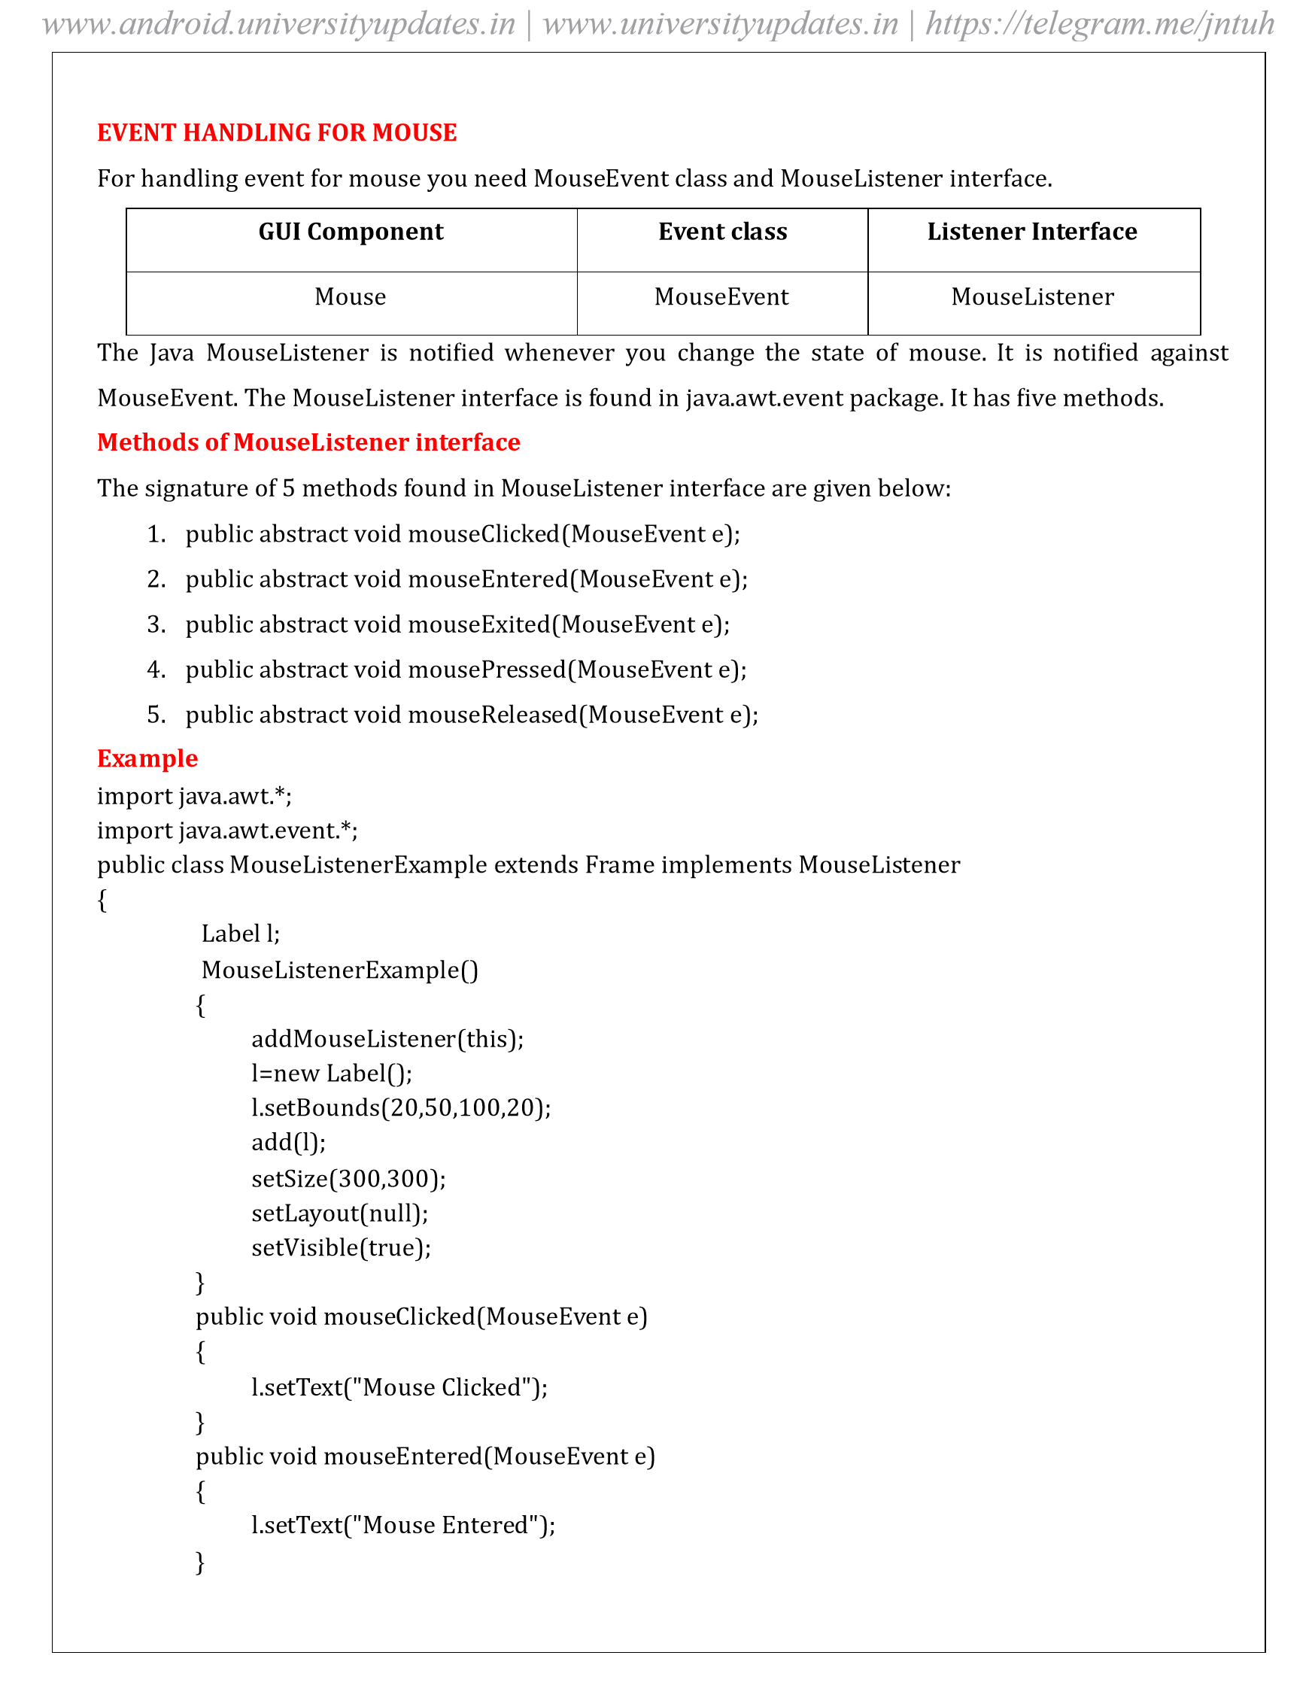
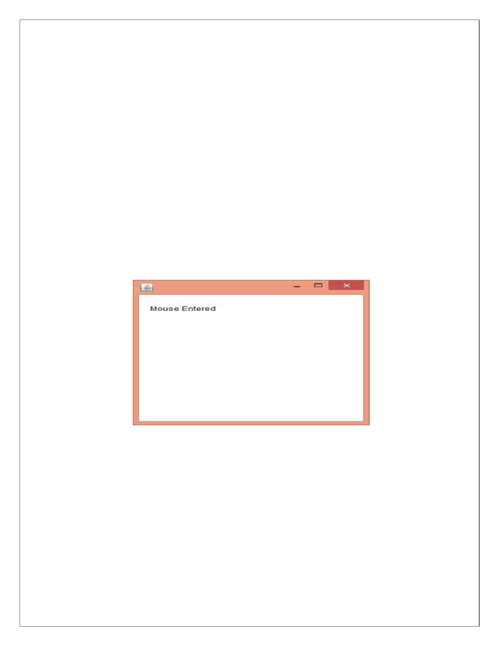

public void mouse
E
xited(MouseEv
ent

e)

{

l
.se
tT
e
xt("Mo
use Exited");

}

public void mouse
Presse
d(Mou
seE
ve
nt

e)

{

l
.se
tT
e
xt("Mo
use Pr
e
ssed");

}

public void mouse
Released(MouseE
vent

e)

{

l
.se
tT
e
xt("Mo
use R
elea
sed");

}

public static void main(String[] args)

{

new Mo
useListene
r
Exa
m
ple();

}

}

Output:

www.android.universityupdates.in | www.universityupdates.in | https://telegram.me/jntuh
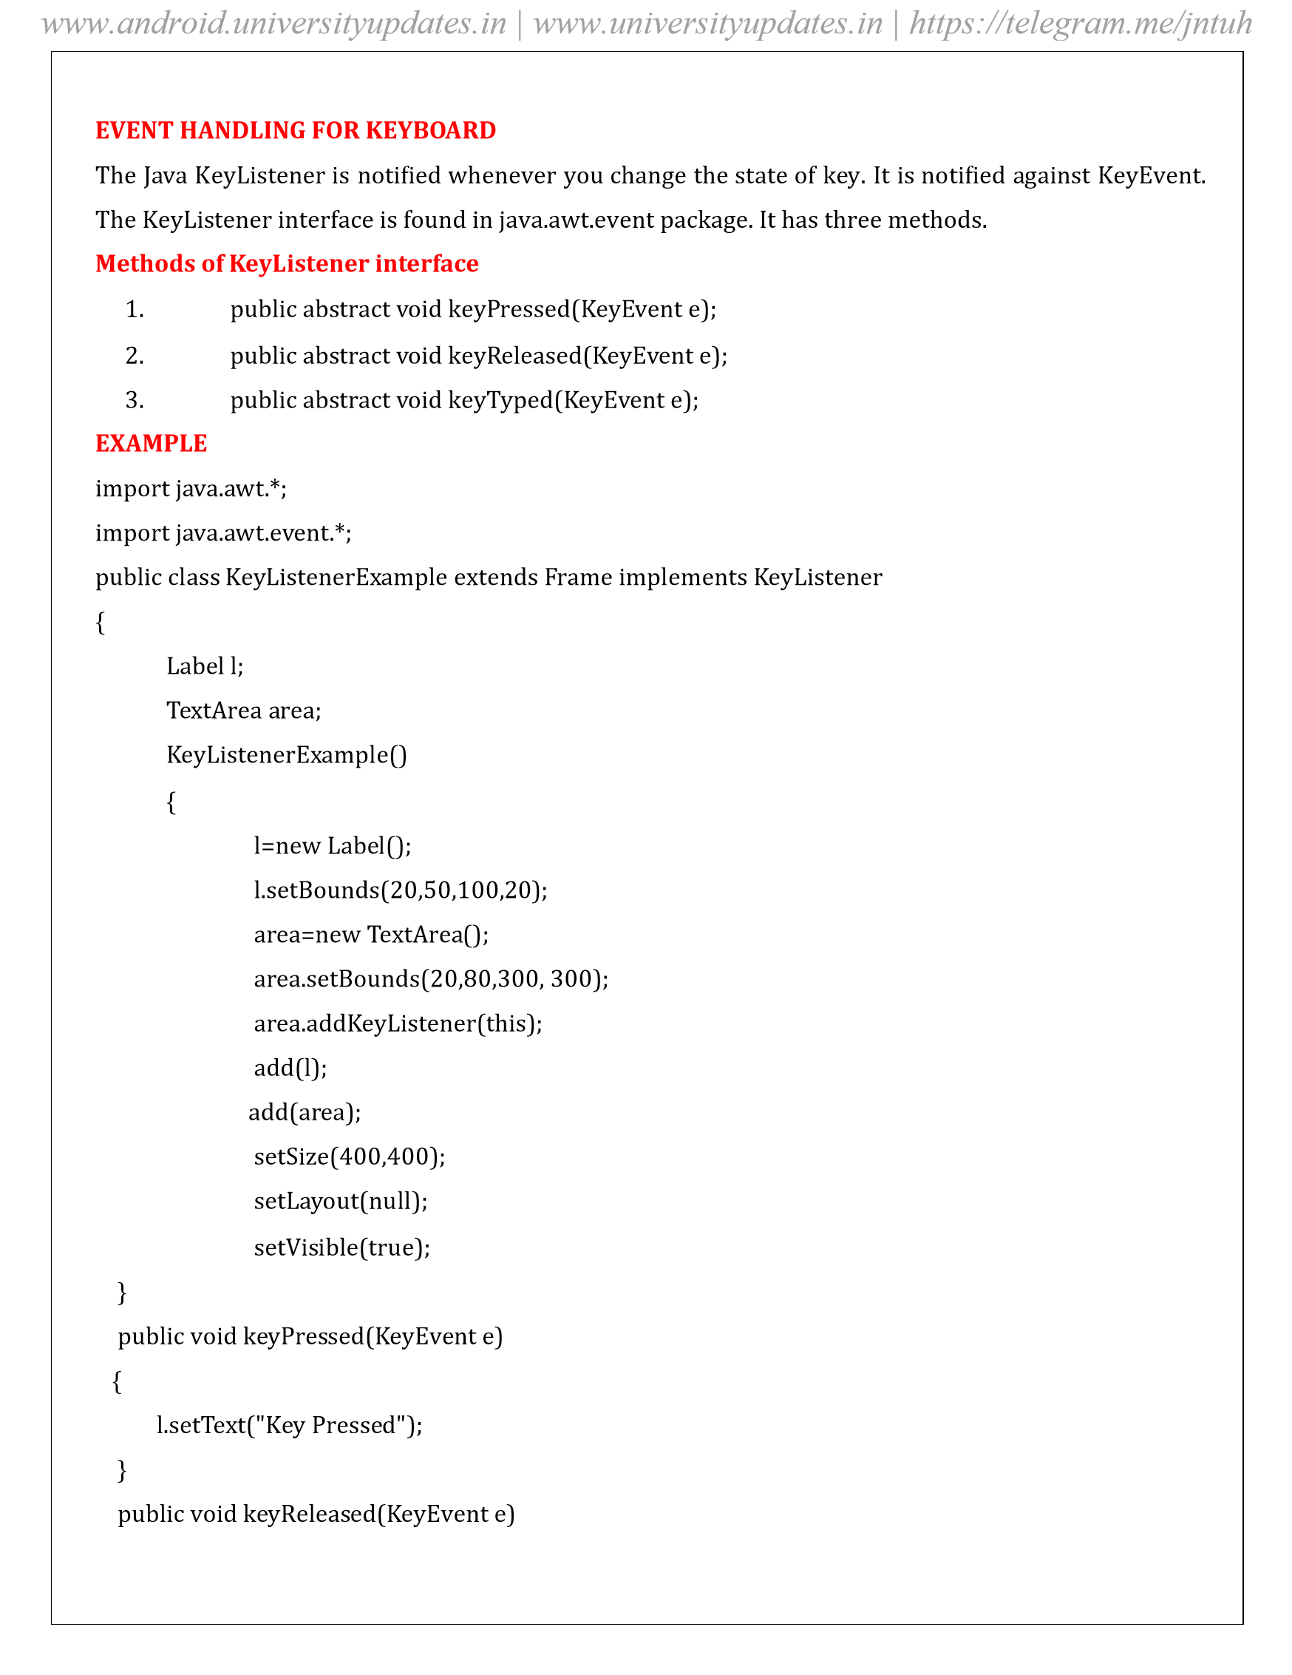
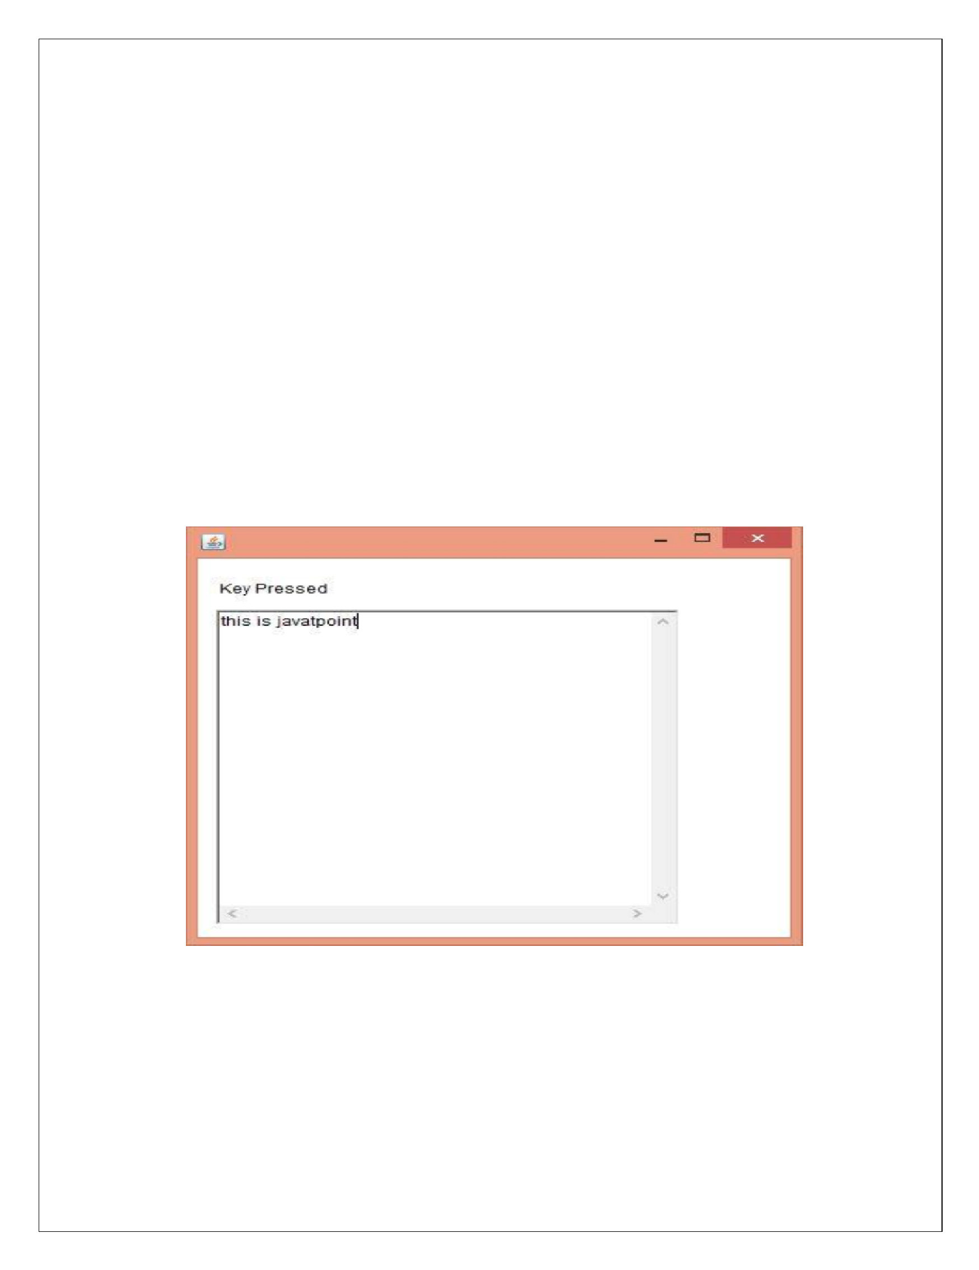
{

l.setT
ex
t("Ke
y
Release
d
"

)
;

}

public
void
ke
yTyped(K
eyEv
ent

e)

{

l.setT
ex
t("Ke
y
Typed"

;
)

}

public
static
void
main(String[]
args)
{

new
K
eyListenerEx
ampl
e();

}
}

Output:

www.android.universityupdates.in | www.universityupdates.in | https://telegram.me/jntuh
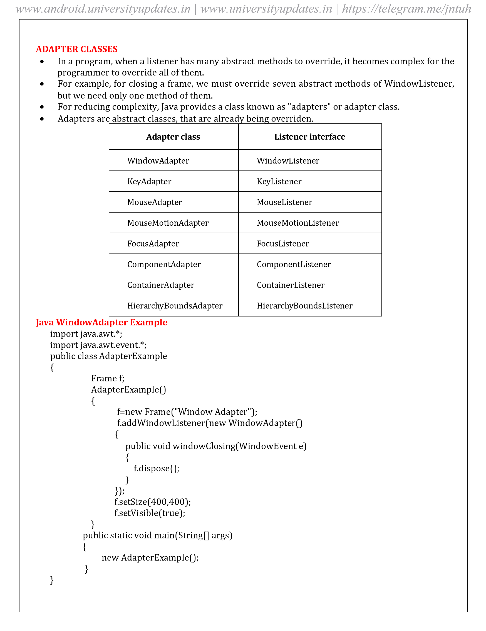
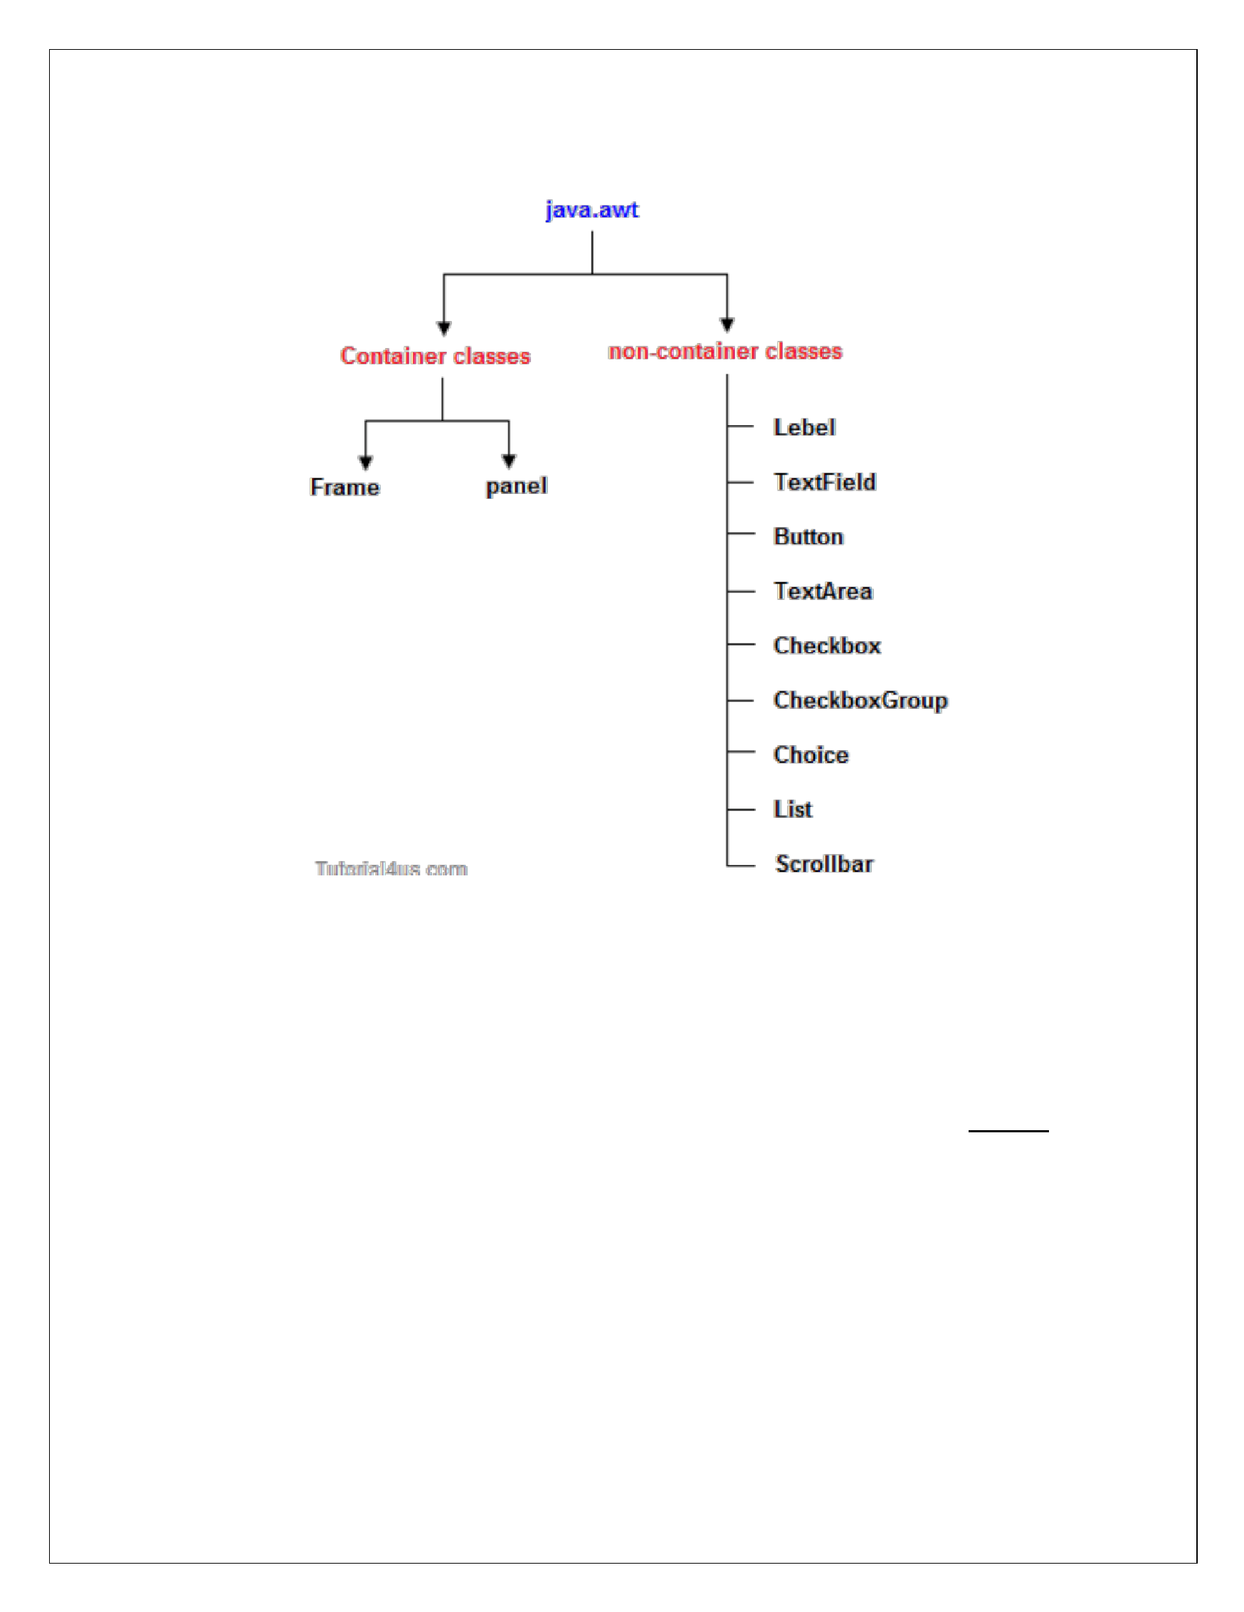
JAVA A
WT HIERAR
C
HY
The hierarchy of Java AWT clas
ses are give
n
bel
ow
.

Components

All
th
e
elements
like
the
button,
text
ields,
scr
ol
l
bars
,
etc.
are
called
compo
nents.
In
Java
AWT,
th
ere
are
classes
for
each
component
as

sho
wn
in
above
d
iagram.
In

order
to
place
ev
ery
co
mponent
in
a

particular position on a scree
n, we ne
ed to
add them to
a container.
Container

The
Container
is
a
compo
nent
in
AWT
that
can
contain
another
com
ponents
like
buttons,
textields,
labels
etc.
The
classes
that
e
xtends
Co
ntainer
class

are

kno
w
n
as
container
s
uch

a
s
F
rame,
Dialog
Panel
and
.

www.android.universityupdates.in | www.universityupdates.in | https://telegram.me/jntuh
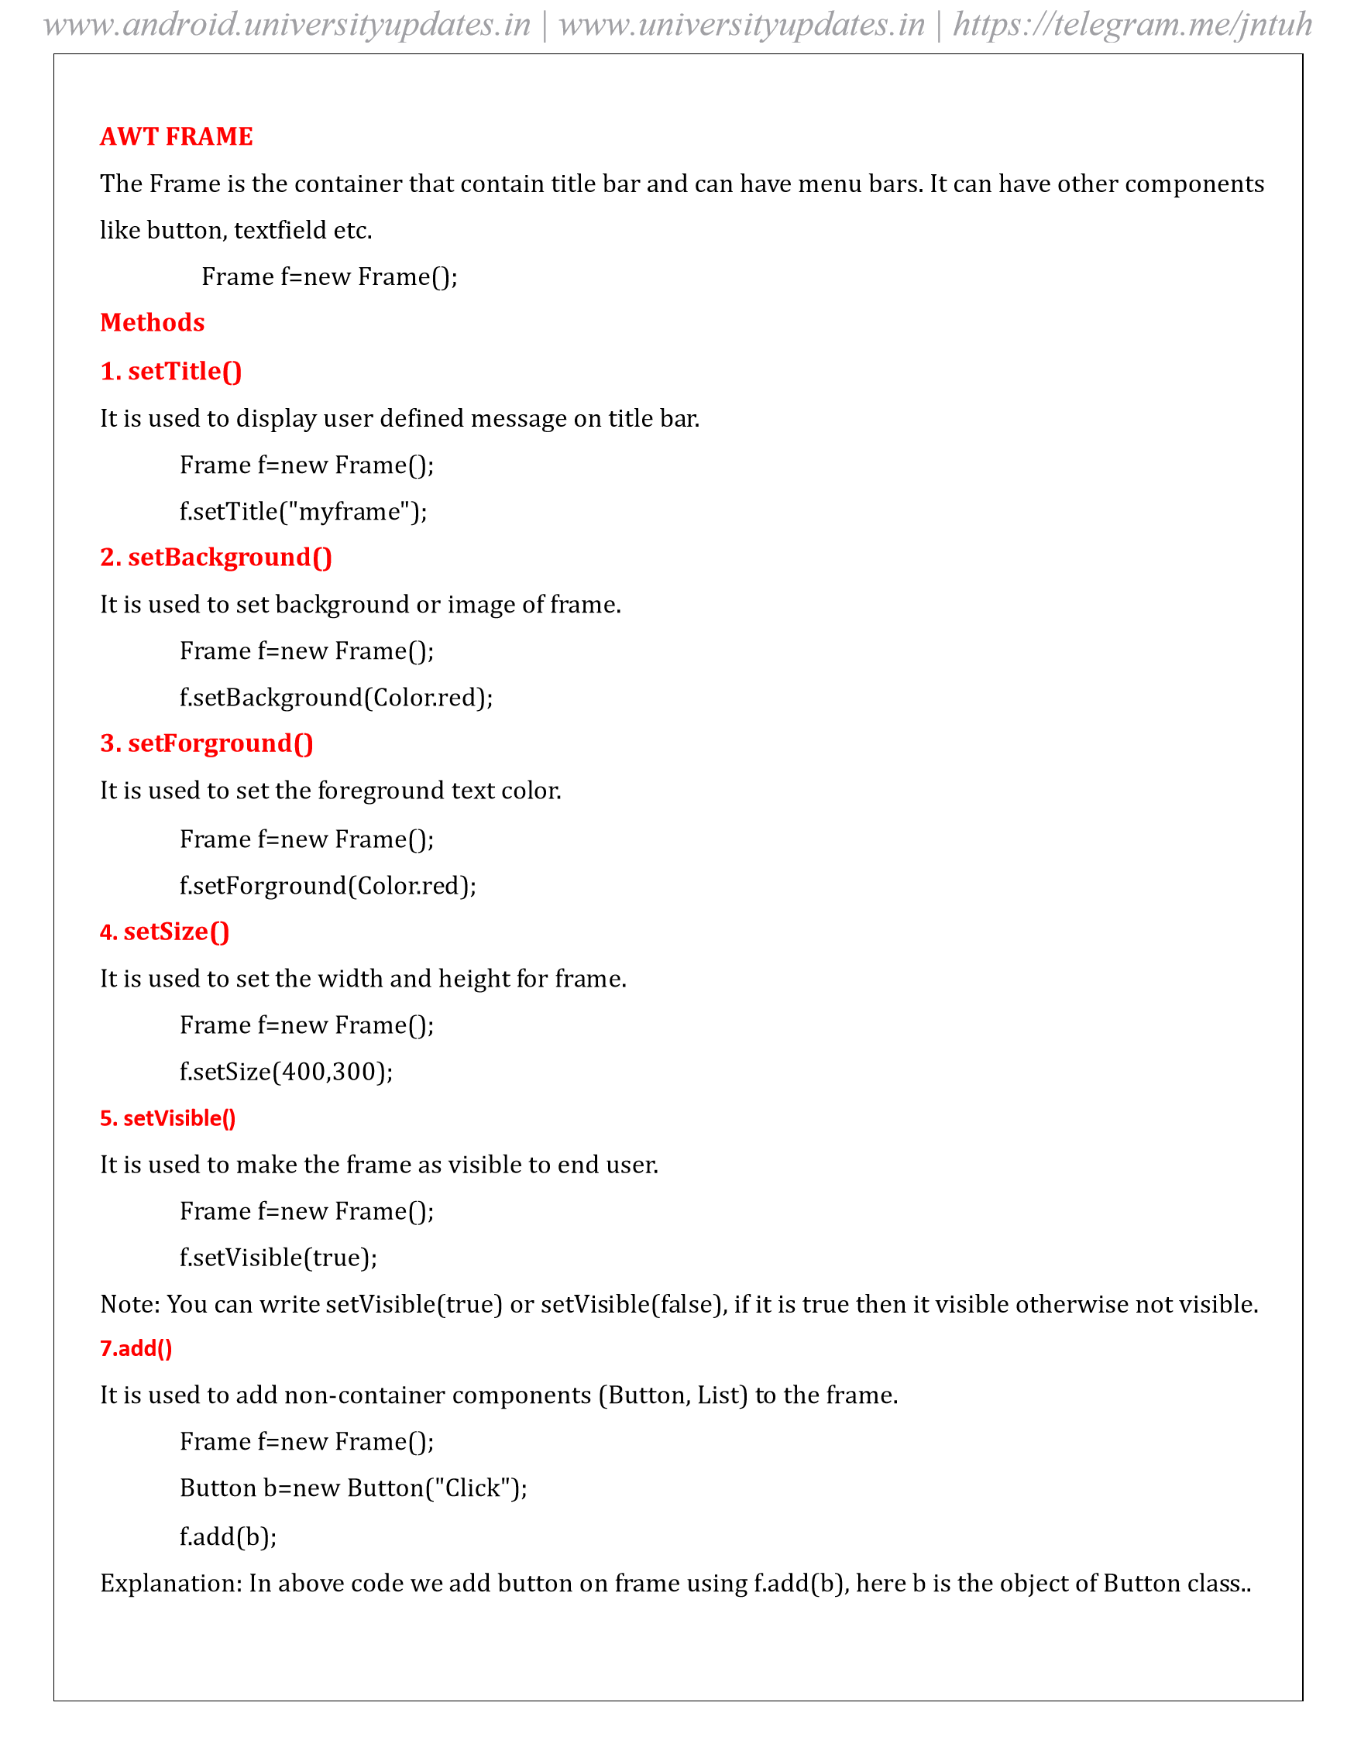
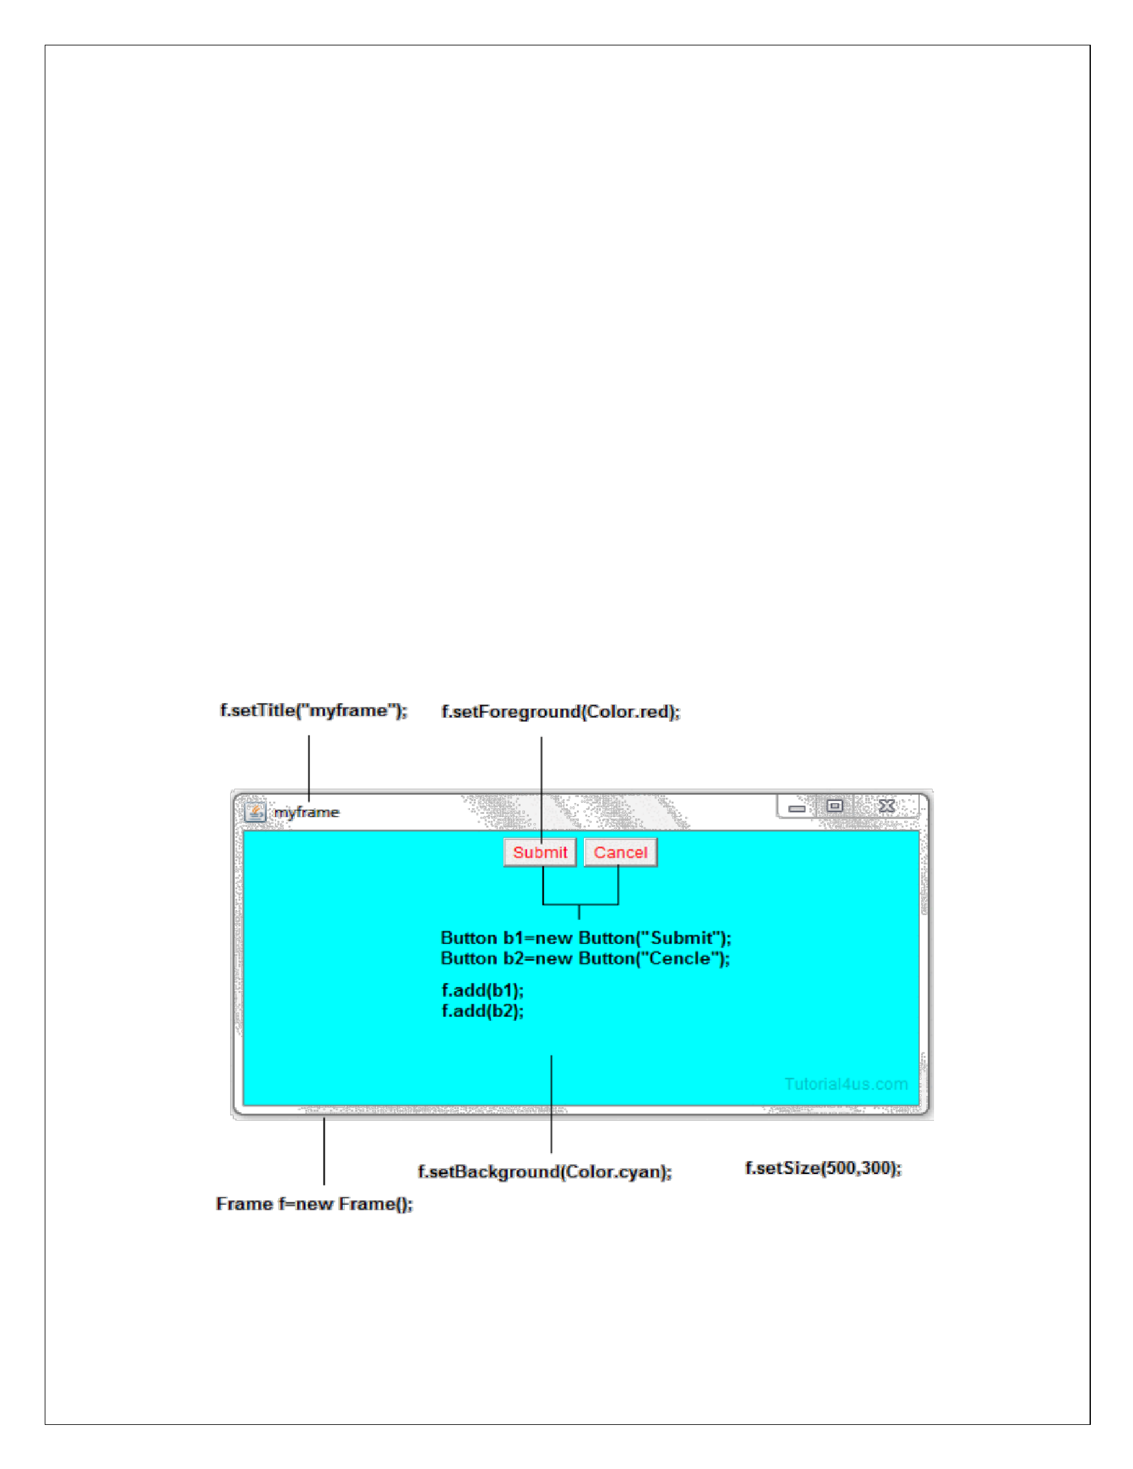
Ex
a
mple

import java.a
w
t.*;

class FrameDe
mo

{

public static void m
ain(String
args)

[]

{

Frame f=new Frame

()
;

f.
setTitle("
myframe"

)
;

f.
setBackgrou
nd(Color
.cyan

)
;

f.
setForegro
und
(
Color.red

)
;

f.
setLayou
t(new Fl
owLayout

())
;

Button
=
new Butto
n("Submit"
b1
)
;

Button
=
new Butto
n("Cance
l
"

b2
)
;

f
.add(

b1
;
)
f.add(
b2
)
;

f
.se
tS
ize(

500
,
300
)
;

f
.se
tVi
sible(true

)
;

}

}

Output

www.android.universityupdates.in | www.universityupdates.in | https://telegram.me/jntuh
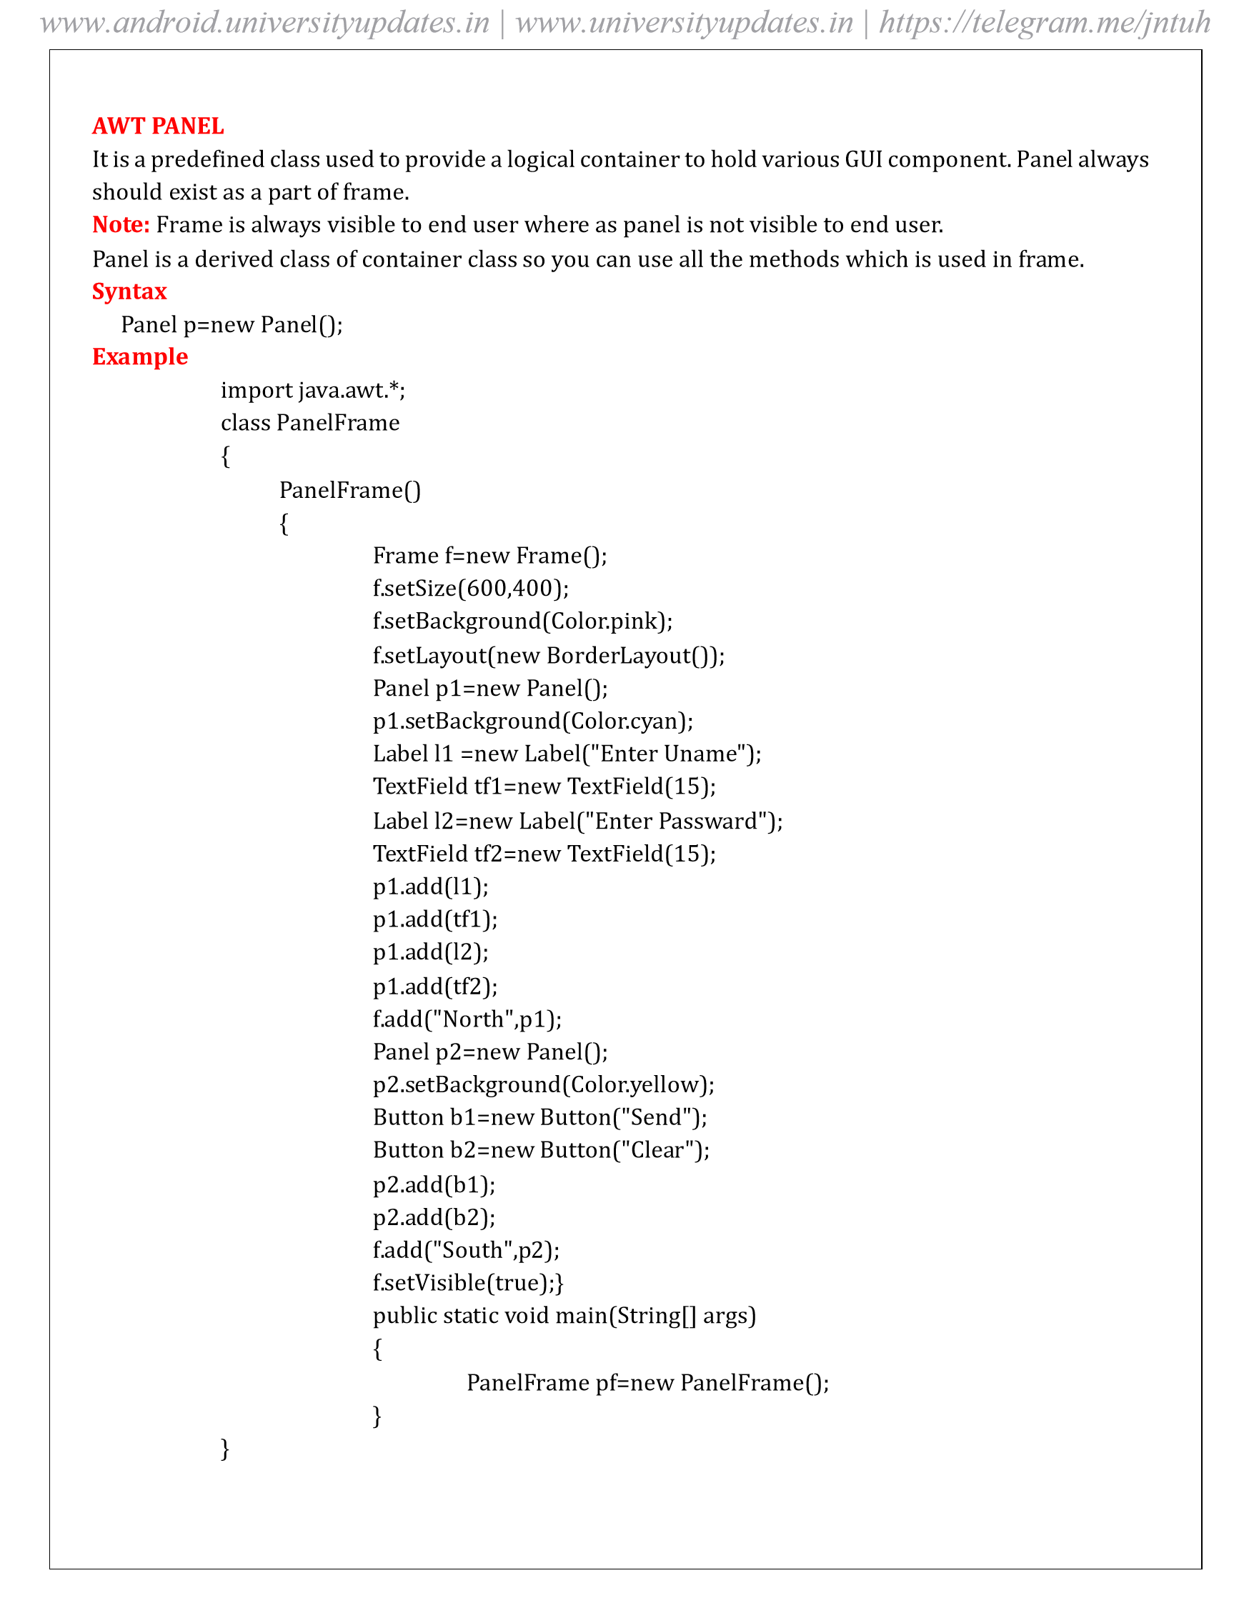
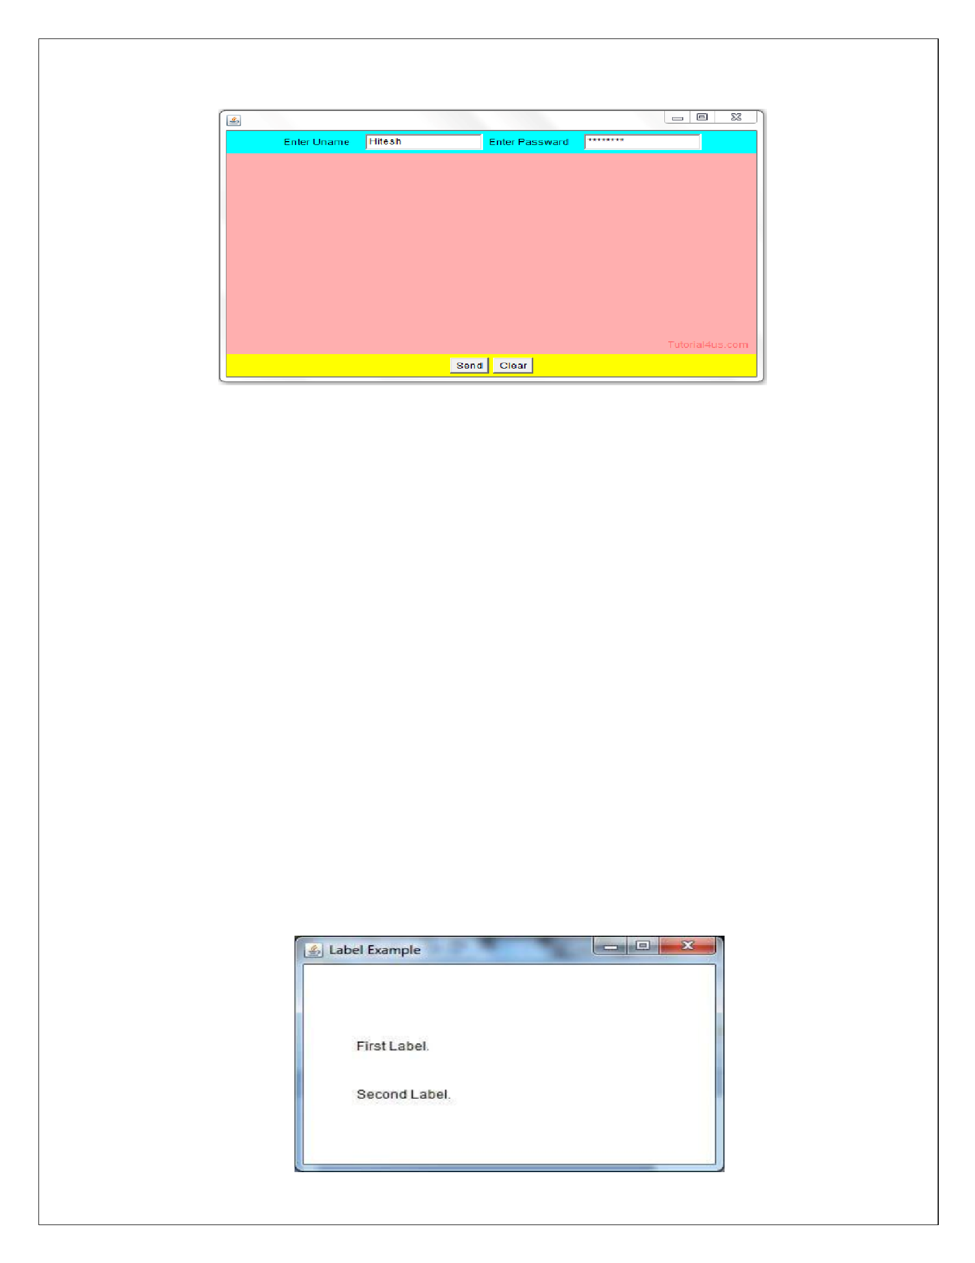
Output:

A
WT Label

The object of
the
Labe
l
class
is
a
compo
nent
for placing
text
in
a co
ntainer. It
is u
sed
to
display
a singl
e
line of read onl
y text. The text can b
e changed b
y a programm
er but a user ca
nn
ot edit it directly.
Example
import java.a
wt.
*;

public cl
ass
L
abe
l
Example

{

public static void m
ain(String args[])

{

Frame f = new Frame ("Label example");

Labe
l l1
, l2;

= new Label ("First Label.");
l1

= new Lab
el ("
Second Label.");
l2

l1.setBound
s(50,
,
100
100, 30);

l2.se
tB
ound
s(50,
150
,
100, 30
)
;

f.add(l1);

f.add(l2
)
;

f.se
tS
ize(400,400
)
;

f.setLayout(nu
ll);

f.setVisible(true);

}

}

Output

www.android.universityupdates.in | www.universityupdates.in | https://telegram.me/jntuh
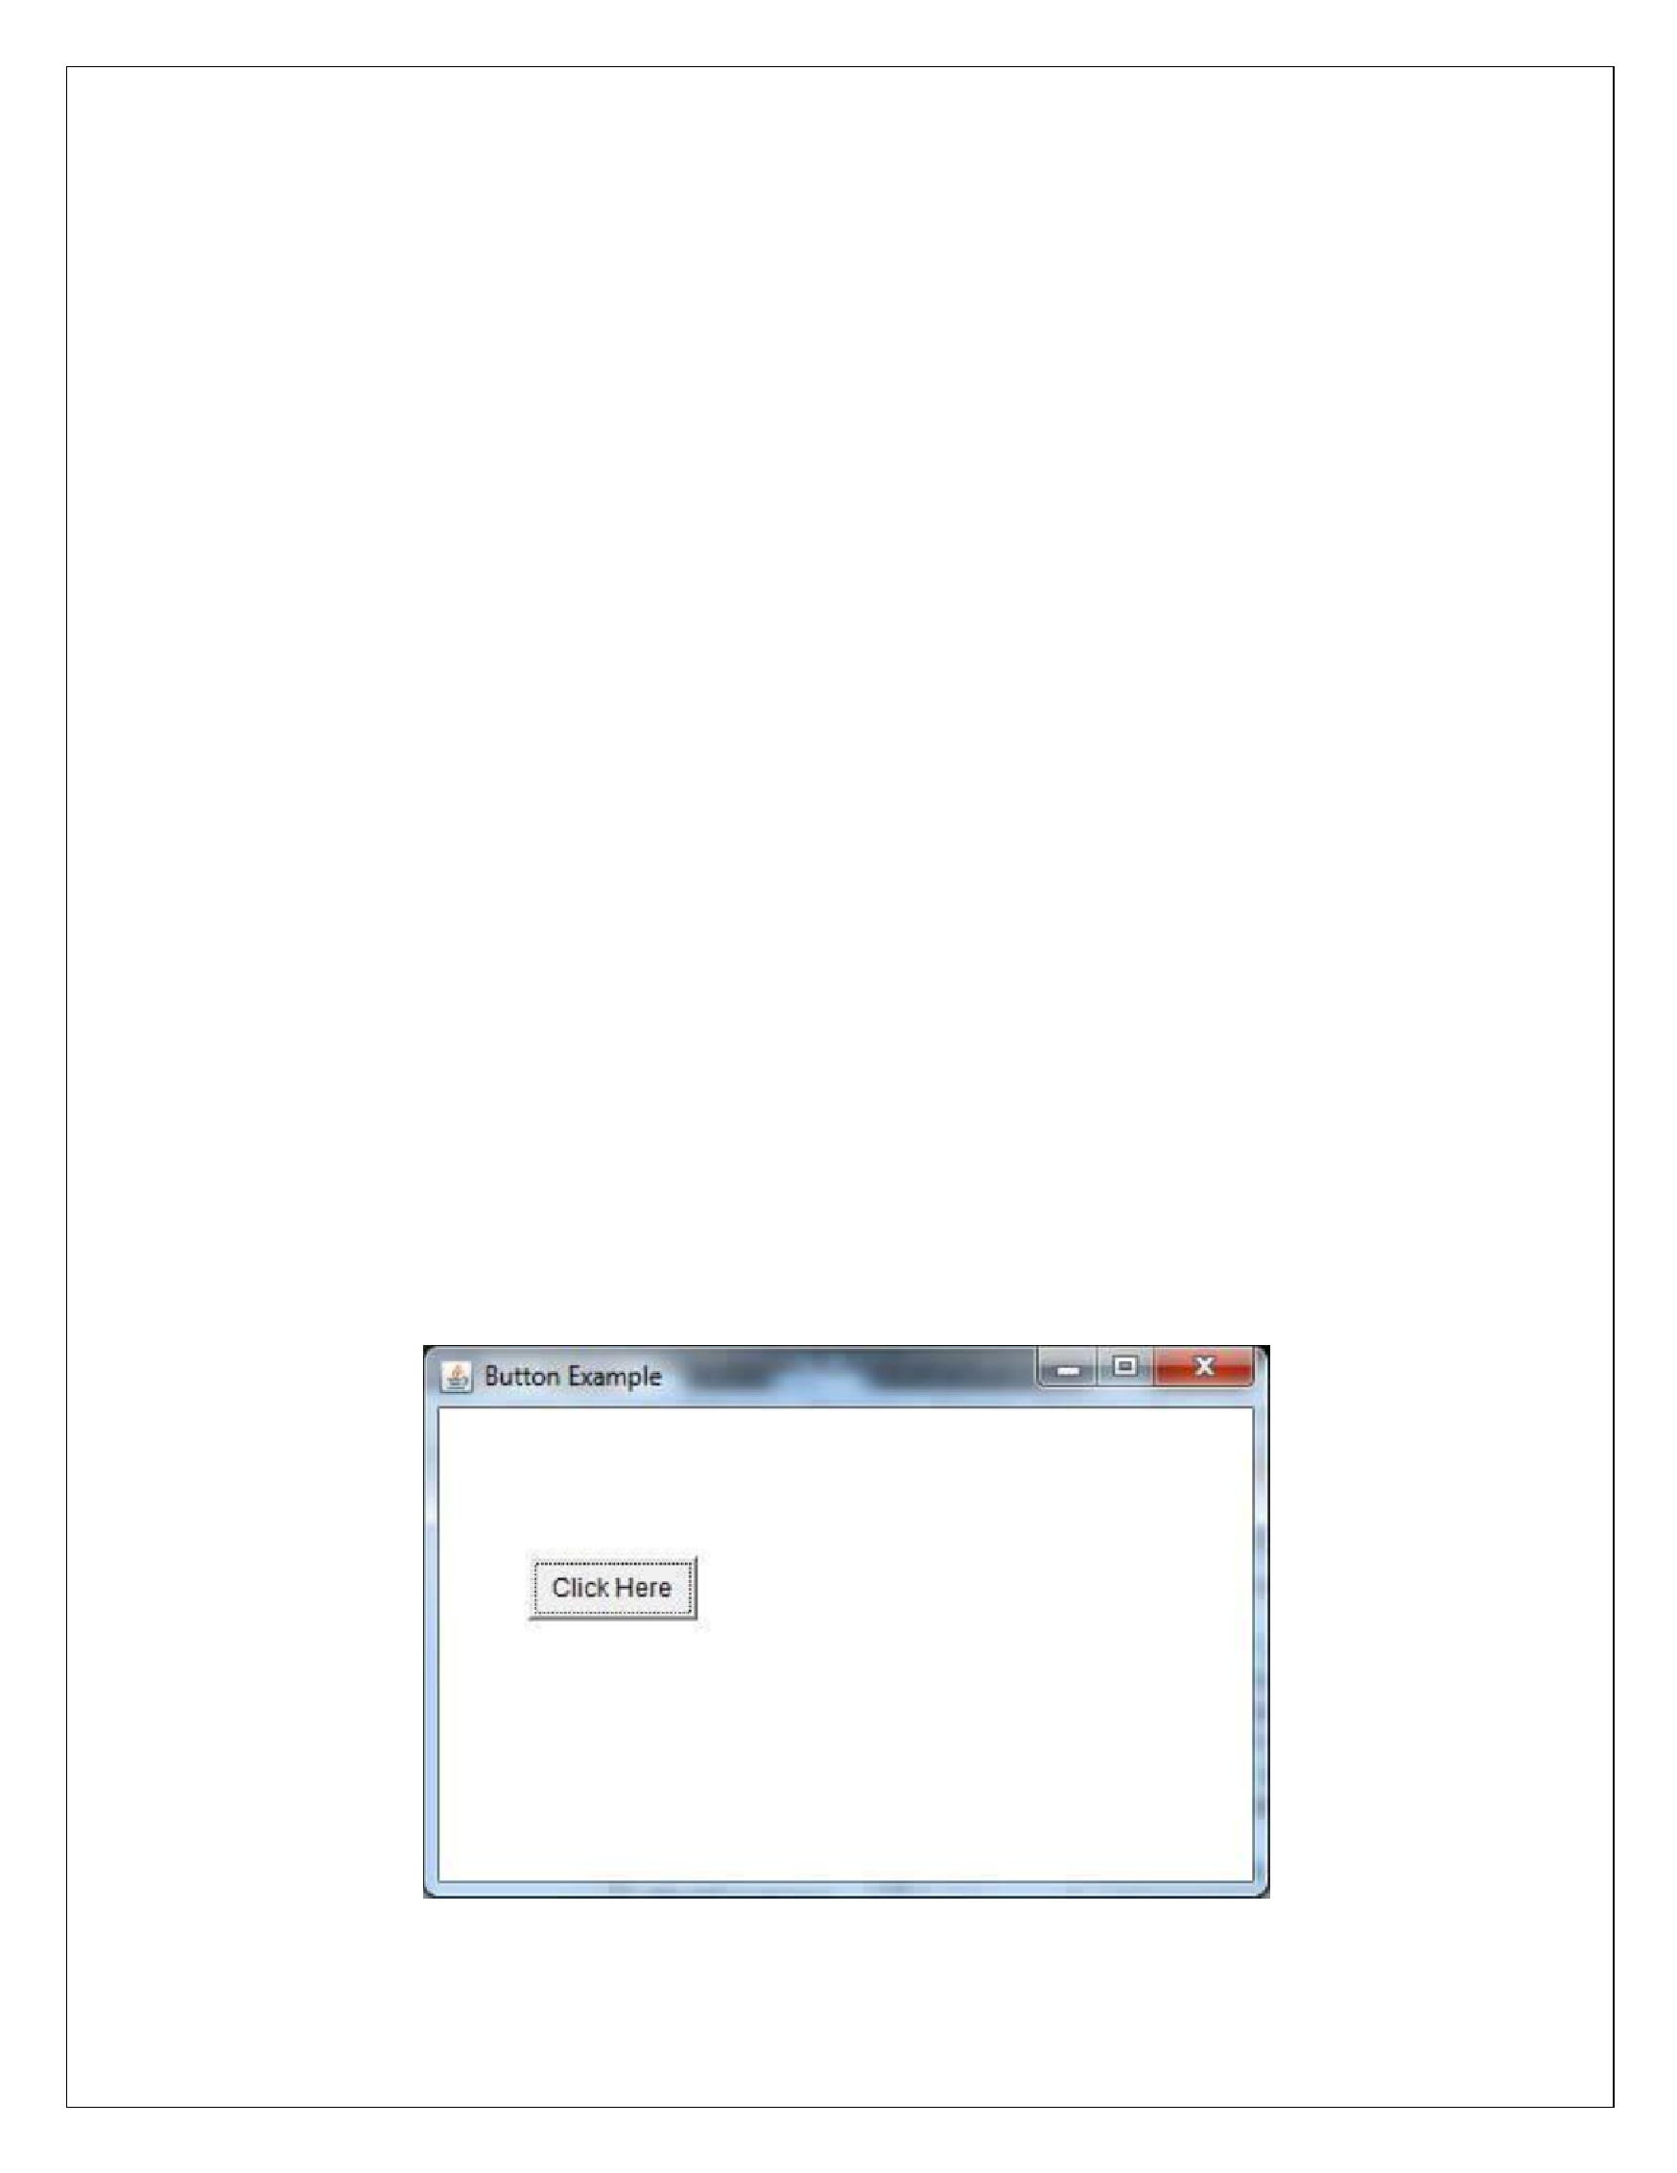
Ja
va A
WT Butt
on

A
button
is
basica
lly
a
cont
rol
component
with
a
label
that
generate
s
an
event
when
pushed.
The Bu
tton class
is
used
to
create a l
abeled button
th
at h
as platform
independe
nt
implementation. Th
e
application result in some action when the button is pushed.

Example
import java.a
w
t.*;

public cl
ass
B
utto
nExa
m
ple
{

public static void m
ain (String[] args)

{

Frame f = new Frame("Button
Example");

Button b = new Bu
tton("Click He
re");

b.s
etBound
s(50,100,80,30);

f.
add(b);

f.se
tS
ize(400,400
)
;

f.setLayout(nu
ll);

f.se
tVi
sible(true);

}

}

Output:

www.android.universityupdates.in | www.universityupdates.in | https://telegram.me/jntuh
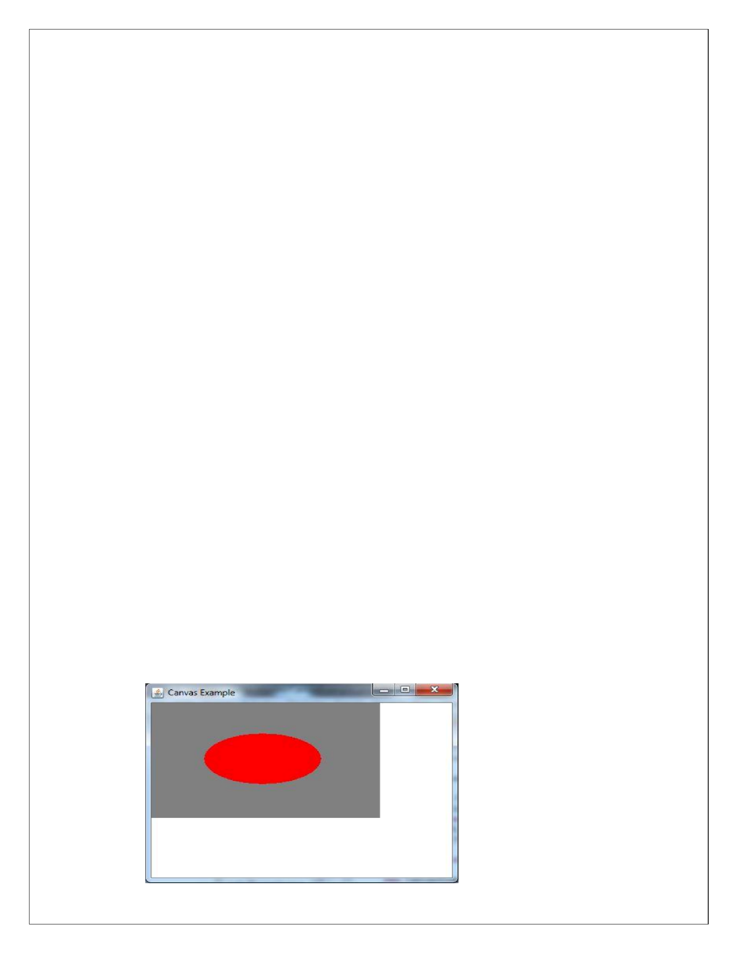
Ja
va A
WT Can
vas

The
Canvas

cl
ass
control
s
and
represe
nt
s
a
b
lank
r
ectangular
area
where
the
application
can
d
raw
or
trap input
events
fr
om th
e user. It inherits the C
o
mponent class.
Example
import java.a
w
t.*;

public cl
ass
CanvasExample

{

public Canvas
E
xample()

{

Frame f = new Frame("Canvas Exa
m
ple");

f.
add(new M
yCanvas());

f.se
tL
ayou
t(null);

f.setSize(400, 40
0)
;

f.setVisible(true);

}
public static void m
ain(String args[])
{

new CanvasExample();

}
}

class MyC
an
vas extends Canvas

{

public M
yCanva
s()

{

s
etBackgro
und
(Color.GRAY);

setSize(300, 200);

}

p
ublic void
paint(Graphics

g)

{

g.setColor(Color.red);

g
.illOval(75,
150, 75);

75
,

}

}

Output:

www.android.universityupdates.in | www.universityupdates.in | https://telegram.me/jntuh
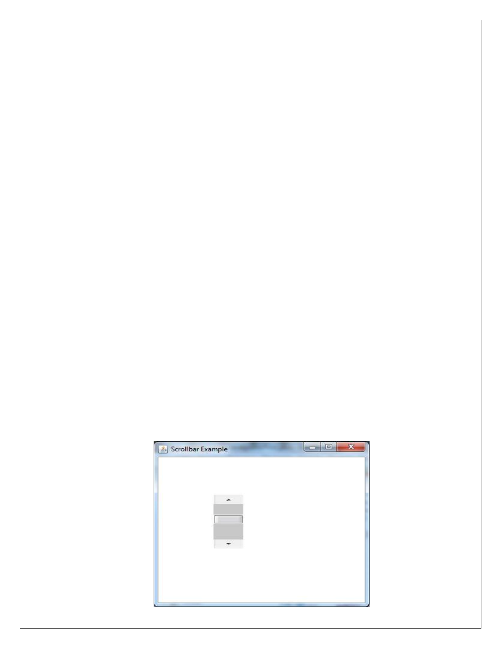
Ja
va A
WT Scr
ollbar

The object of
Scrollbar
class

is
us
ed
to
add
h
orizontal
and
ve
r
tical
scrollbar.
Scrollba
r

is
a GUI component allows us to see invis
ibl
e number of rows and columns.

Example
import java.a
w
t.*;

public cl
ass
S
crollbarExample1

{

ScrollbarExample1()

{

Frame f = new Frame("Scrollbar Example");

Scr
ollbar s = new Scrollbar();

s.setBounds (100,
50, 100);

100
,

f.add(s);

f.se
tS
ize(400, 40
;
0)

f.se
tL
ayou
t(null);

f.se
tVi
sible(true);

}

public static void main(String args[])

{

new S
crollbarExample1();
}

}

Output:

www.android.universityupdates.in | www.universityupdates.in | https://telegram.me/jntuh
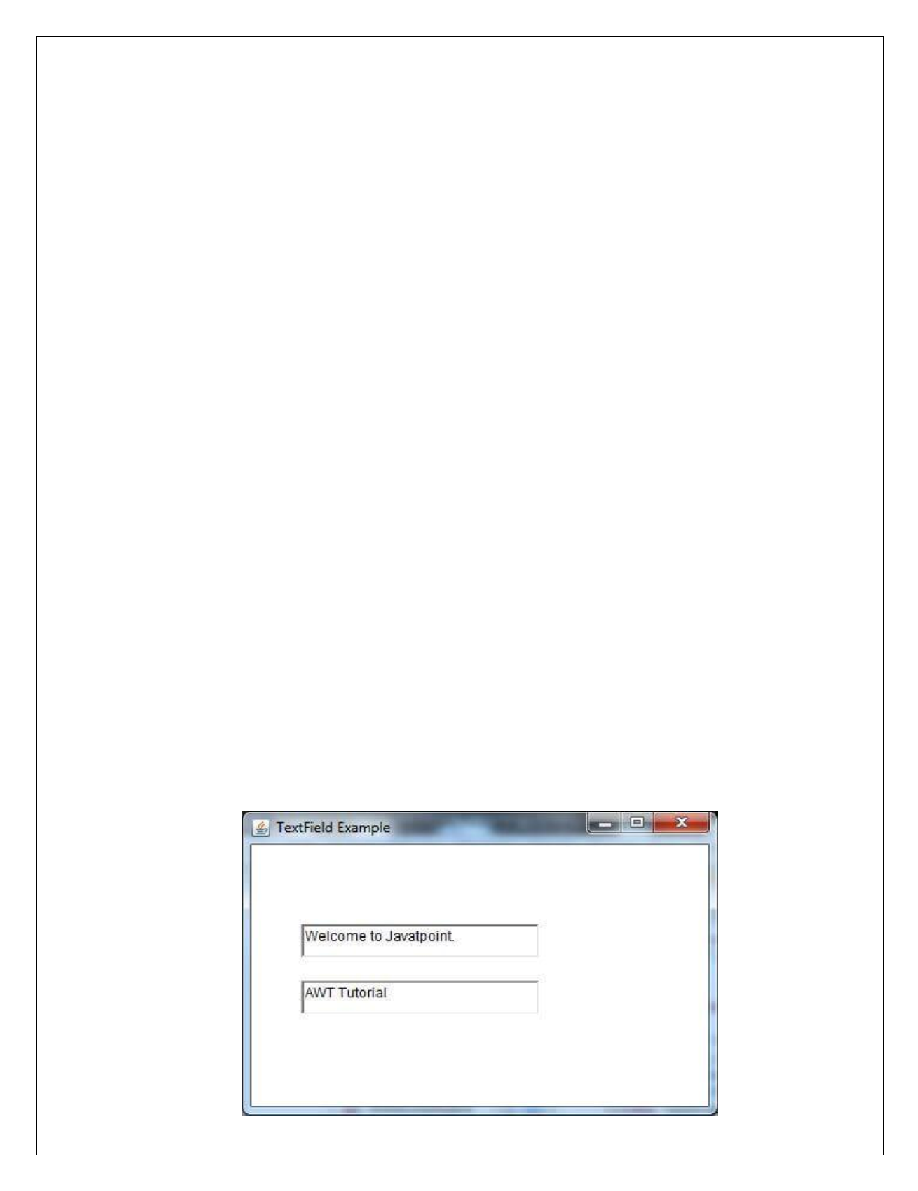
Ja
va A
WT T
extF
i
eld

The object of
a TextField class is
a
t
ext com
ponent that
allo
ws a
user
to
enter a
single lin
e text
a
nd
edit

it. It inherits TextCompo
nent clas
s, which
further inherits Com
ponent class
.

Exmple:
import java.a
w
t.*;

public cl
ass
T
extFieldExample1

{

p
ublic static void m
ain(String args[])

{

Frame f = new Frame("TextField
Example");

Tex
tF
ield t1
, t2;

= new TextField("Welcome
Java
tpoint.");
t1
to

t1
.setBounds(50, 100,
30);

,
200

= new TextField("AWT Tu
torial");
t2

t2
.setBounds(50, 150,
30);

200
,

f.add(t1);

f.add(t2);

f.setSize(400,400);

f.setLayout(nu
ll);

f.setVisible(true);

}

}

Output:

www.android.universityupdates.in | www.universityupdates.in | https://telegram.me/jntuh
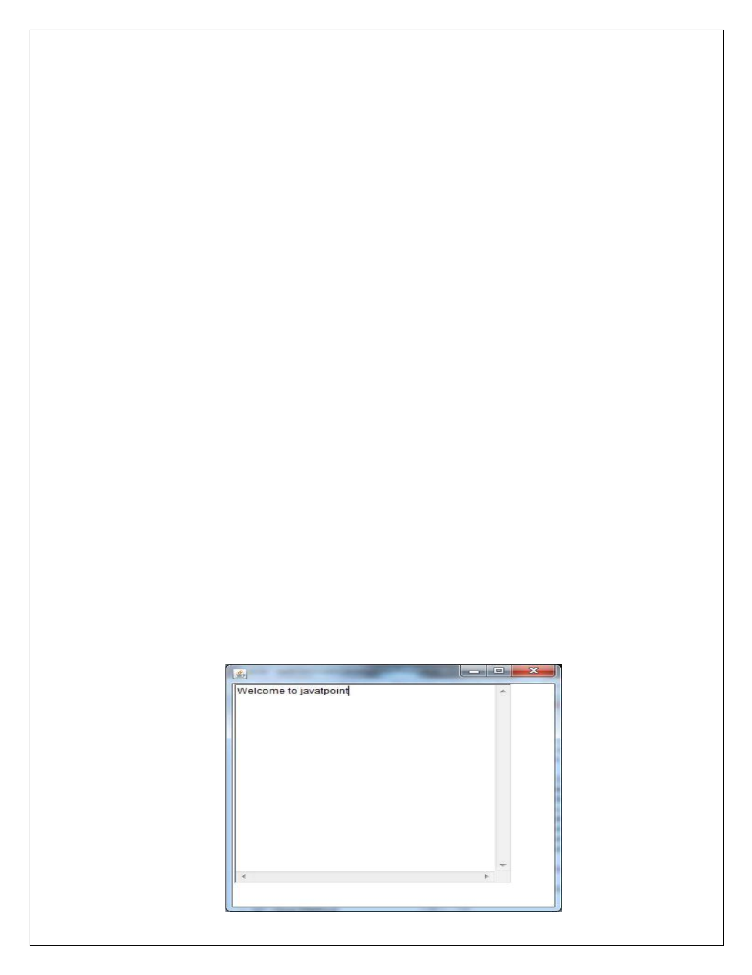
Ja
va A
WT T
extAr
ea

The object of
a
TextArea
class
i
s
a
m
ultil
ine
region
that
displays
text.
It a
l
low
s
the
editing
of
m
ultiple
line
text. It inherits TextComponent cl
ass
.

Example
import java.a
w
t.*;

public cl
ass
T
extAreaExa
m
ple

{

TextAreaExa
m
ple()

{

Fra
me f = new Frame();

TextArea a
r
ea = new T
extArea
"Welcome
(
javatpoint"
;
)
to

a
rea.setBou
nds(10,
300, 300);
30
,

f.
add(area);

f.
setSize(400, 40
0)
;

f.
setLayou
t(null);

f.
setVisible(true);

}

public static void m
ain(String args[])

{

new T
extAreaExa
m
ple();

}

}

Output

www.android.universityupdates.in | www.universityupdates.in | https://telegram.me/jntuh
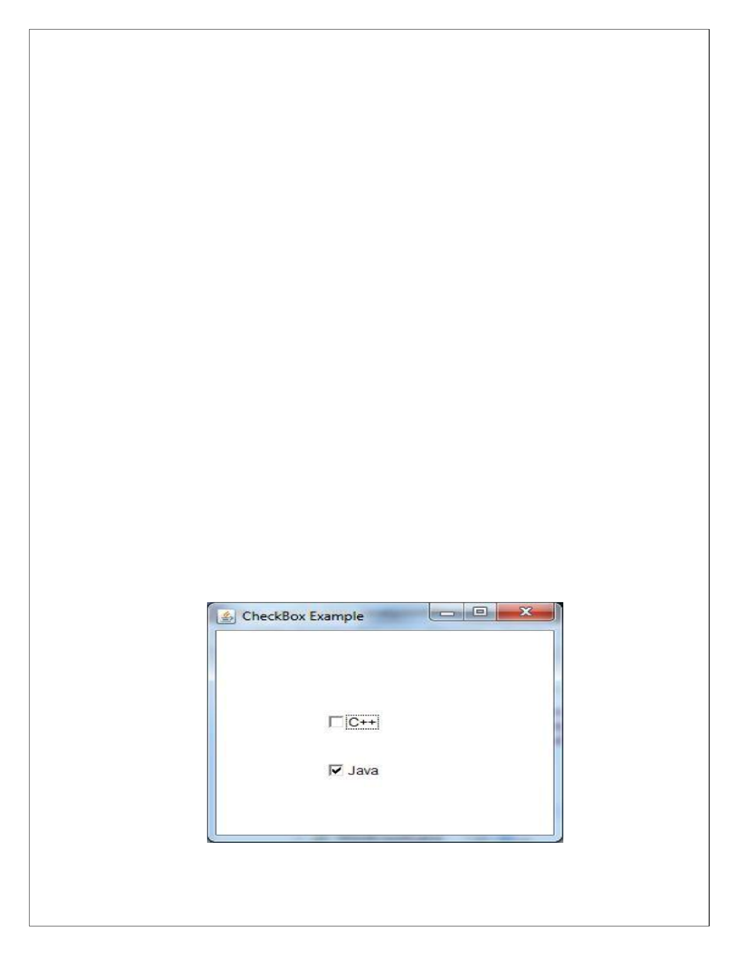
Ja
va A
WT Chec
kbox

The
C
heckbox
class
i
s
used
to
create
a

ch
eckbo
x.
It
is
used
to
turn
an
optio
n
o
n
(
t
ru
e)
or
off

(
false
).

Clicking on a Checkbox changes its s
tat
e from "
on" to "off" or from "off" to "on".
Example
import java.a
w
t.*;

public cl
ass
Ch
eckboxExample1
{

CheckboxExample1()
{

Frame f = new Frame("Checkbox Example");

C
h
eckbox checkbox1 = new Checkbox("C++");

che
ckbox1.se
tB
ou
nds(100, 1
00
,
50);

50
,

C
h
eckbox
eckbox2 = new Checkbox("Java", true);
ch
checkbox2.se
tB
ound
s(100, 1
50
,
50
,
50);

f.
add(checkbox1);

f.
add(checkbox2);

f.se
tSiz
e(400,400);

f.
setLayou
t(null);

f.
setVisible(true);

}
public static void m
ain (String args[])

{

new Ch
eckboxExample1();
}

}

Output

www.android.universityupdates.in | www.universityupdates.in | https://telegram.me/jntuh
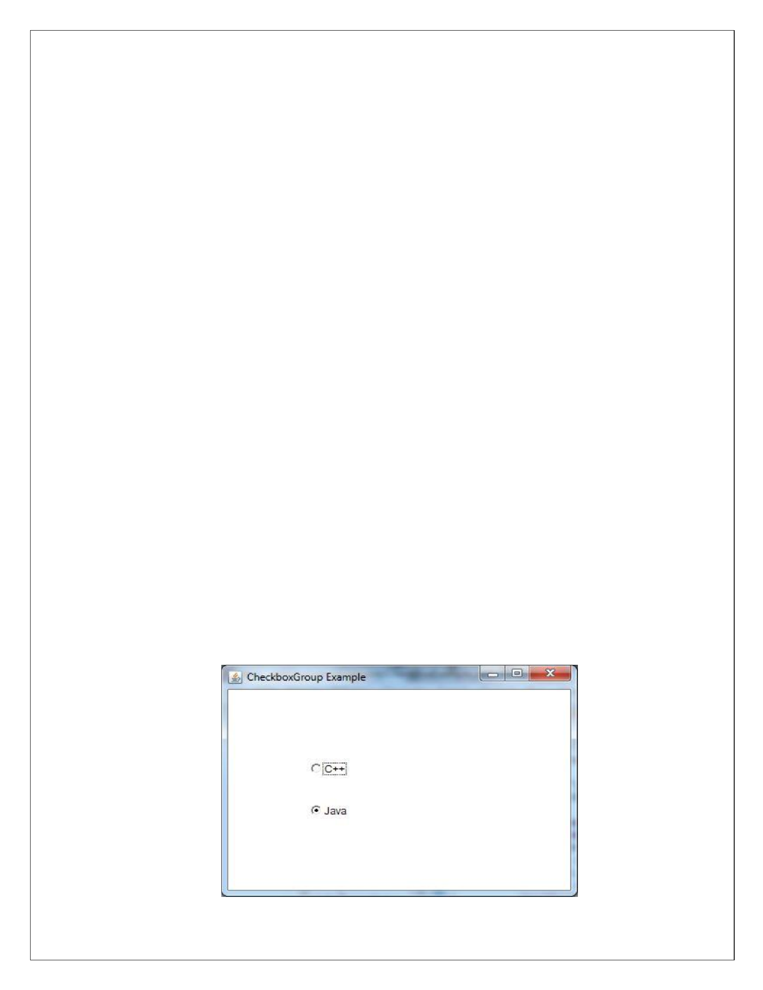
Ja
va A
WT Chec
kboxG
roup

The obje
ct of C
heckboxGr
oup class
is
u
sed to
grou
p toget
h
er a
set of
Checkbox. At a
time only
one check
box
button
is

a
l
lowed
to
be
in
"on"
state
and

remaining
check
box
button
in
"off"
sta
te.
It
inh
erits
the object class.
Example
import java.a
w
t.*;

public cl
ass
Ch
eckboxGroupE
xample
{

CheckboxGroupExample()
{

Frame
new Frame("CheckboxGroup
Example");
f=

Che
ckboxGrou
p cbg = new CheckboxGroup();

Che
ckbox checkBox1 = new Ch
eckbox("C++", cbg, fa
l
se);

check
B
ox1.setBound
s(100,10
0
,
50,50
)
;

Che
ckbox checkBox2 = new Ch
eckbox("Ja
va", c
bg, tru
e);

check
B
ox2.setBound
s(100,15
0
,
50,50
)
;

f.add(checkBox1);

f.
add(ch
eckBox2);

f.
setSize(400,400
;
)

f.
setLayou
t(null);

f.
setVisible(true);

}
public static void m
ain(String args[])

{

new Ch
eckboxGroupExample();
}

}

Output

www.android.universityupdates.in | www.universityupdates.in | https://telegram.me/jntuh
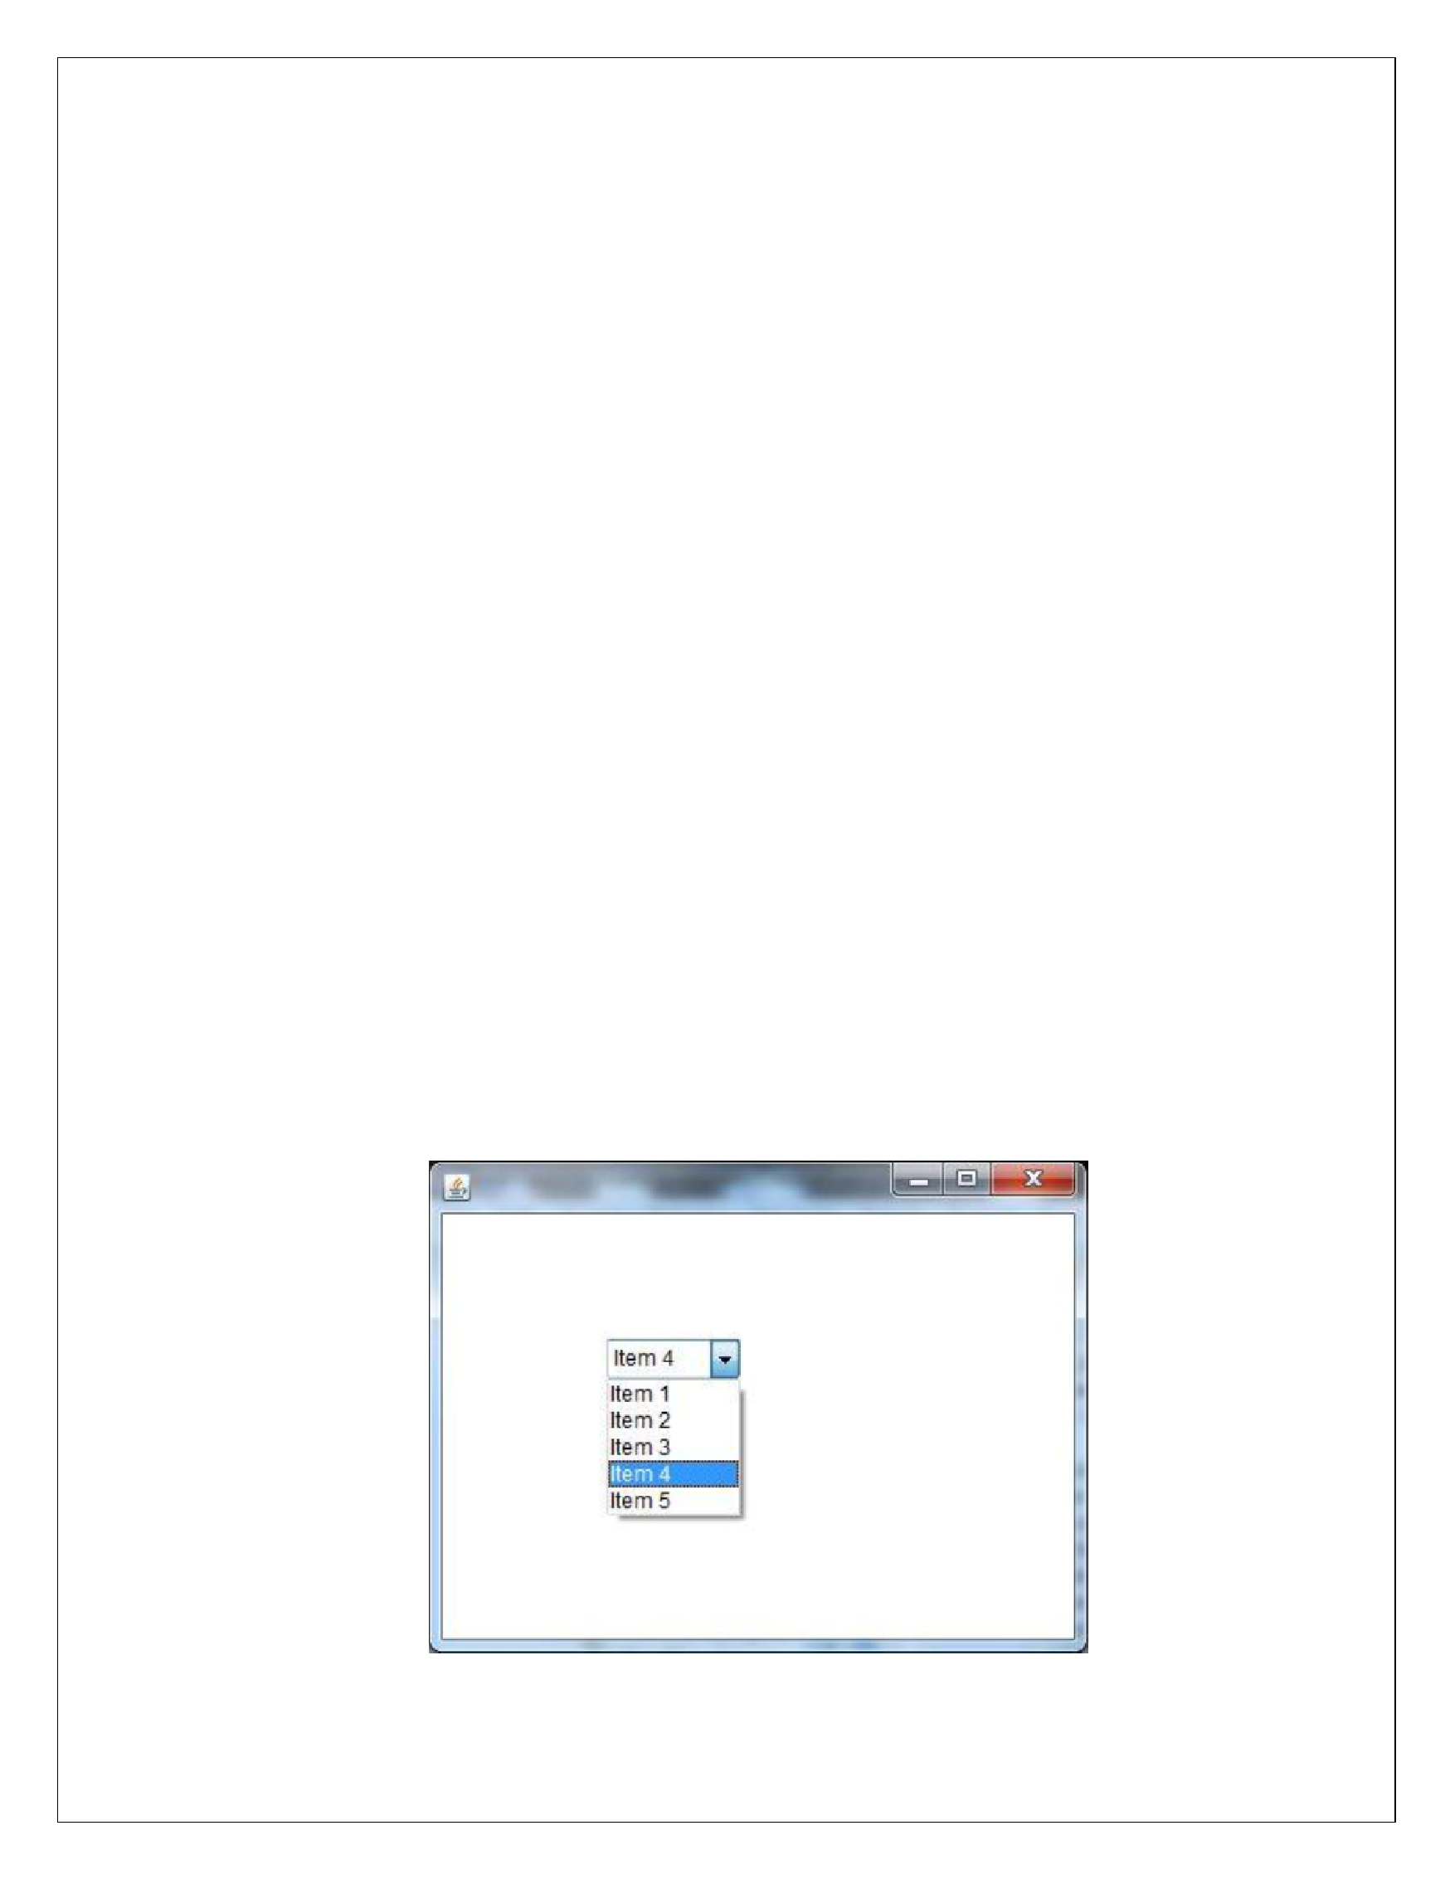
Ja
va A
WT Choice

The
object of
Cho
ice cl
ass
is
u
sed to
show
p
opup menu o
f ch
oices. Cho
ice s
elected
by u
ser
is
sh
ow
n
on
the top o
f a menu. It inher
its Component class
.

Example
import java.a
w
t.*;

public cl
ass
Ch
oiceExample1
{

ChoiceExample1()
{

Frame f = new Frame();

Choice c = new Choice();

c.setBounds(100,
100,
75);

75
,

c.add("Item 1"
;
)

c.add("Item 2");

c.
add("
Item 3");

c.
add("
Item 4");

c.
add("
Item 5");

f.add(c);

f.setSize(400, 400);

f.
setLayou
t(null);

f.
setVisible(true);

}

pu
blic static void main(String args[])
{

new Ch
oiceExample1();
}

}

Outpu
t

www.android.universityupdates.in | www.universityupdates.in | https://telegram.me/jntuh
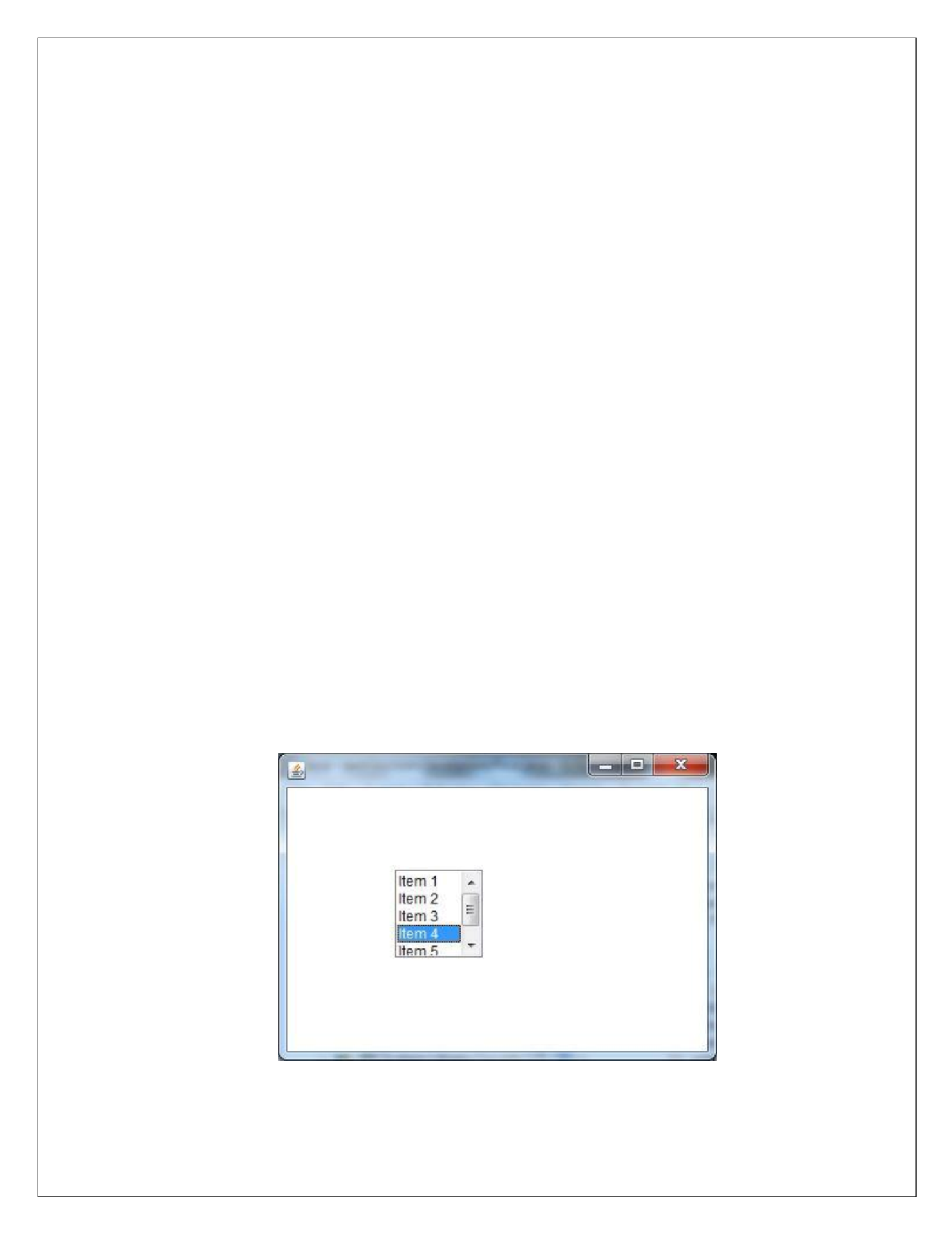
Ja
va A
WT List

The
object
of
List
class
represents

a
list
of
text
it
ems.
With
th
e
help

of
the
List
cl
ass
,
u
ser
can

choose
either one item or
mu
l
tiple items. It inherits the
Co
mponent class.

Example
import java.a
w
t.*;

public cl
ass
L
istExample1
{

ListExample1()
{

Frame f = new Frame();

List
= new List(5);

l1

l1.setBou
nds(100,

100
,
,
75
75);

l1.add("Item 1"
)
;

l1.add("Item 2");

l1.add("Item 3");

l1.add("Item 4");

l1.add("Item 5");

f.add(l1);

f.setSize(400, 400);

f.
setLayou
t(null);

f.
setVisible(true);

}

pu
blic static void main(String args[])
{

new L
istExample1();
}

}

Output

www.android.universityupdates.in | www.universityupdates.in | https://telegram.me/jntuh
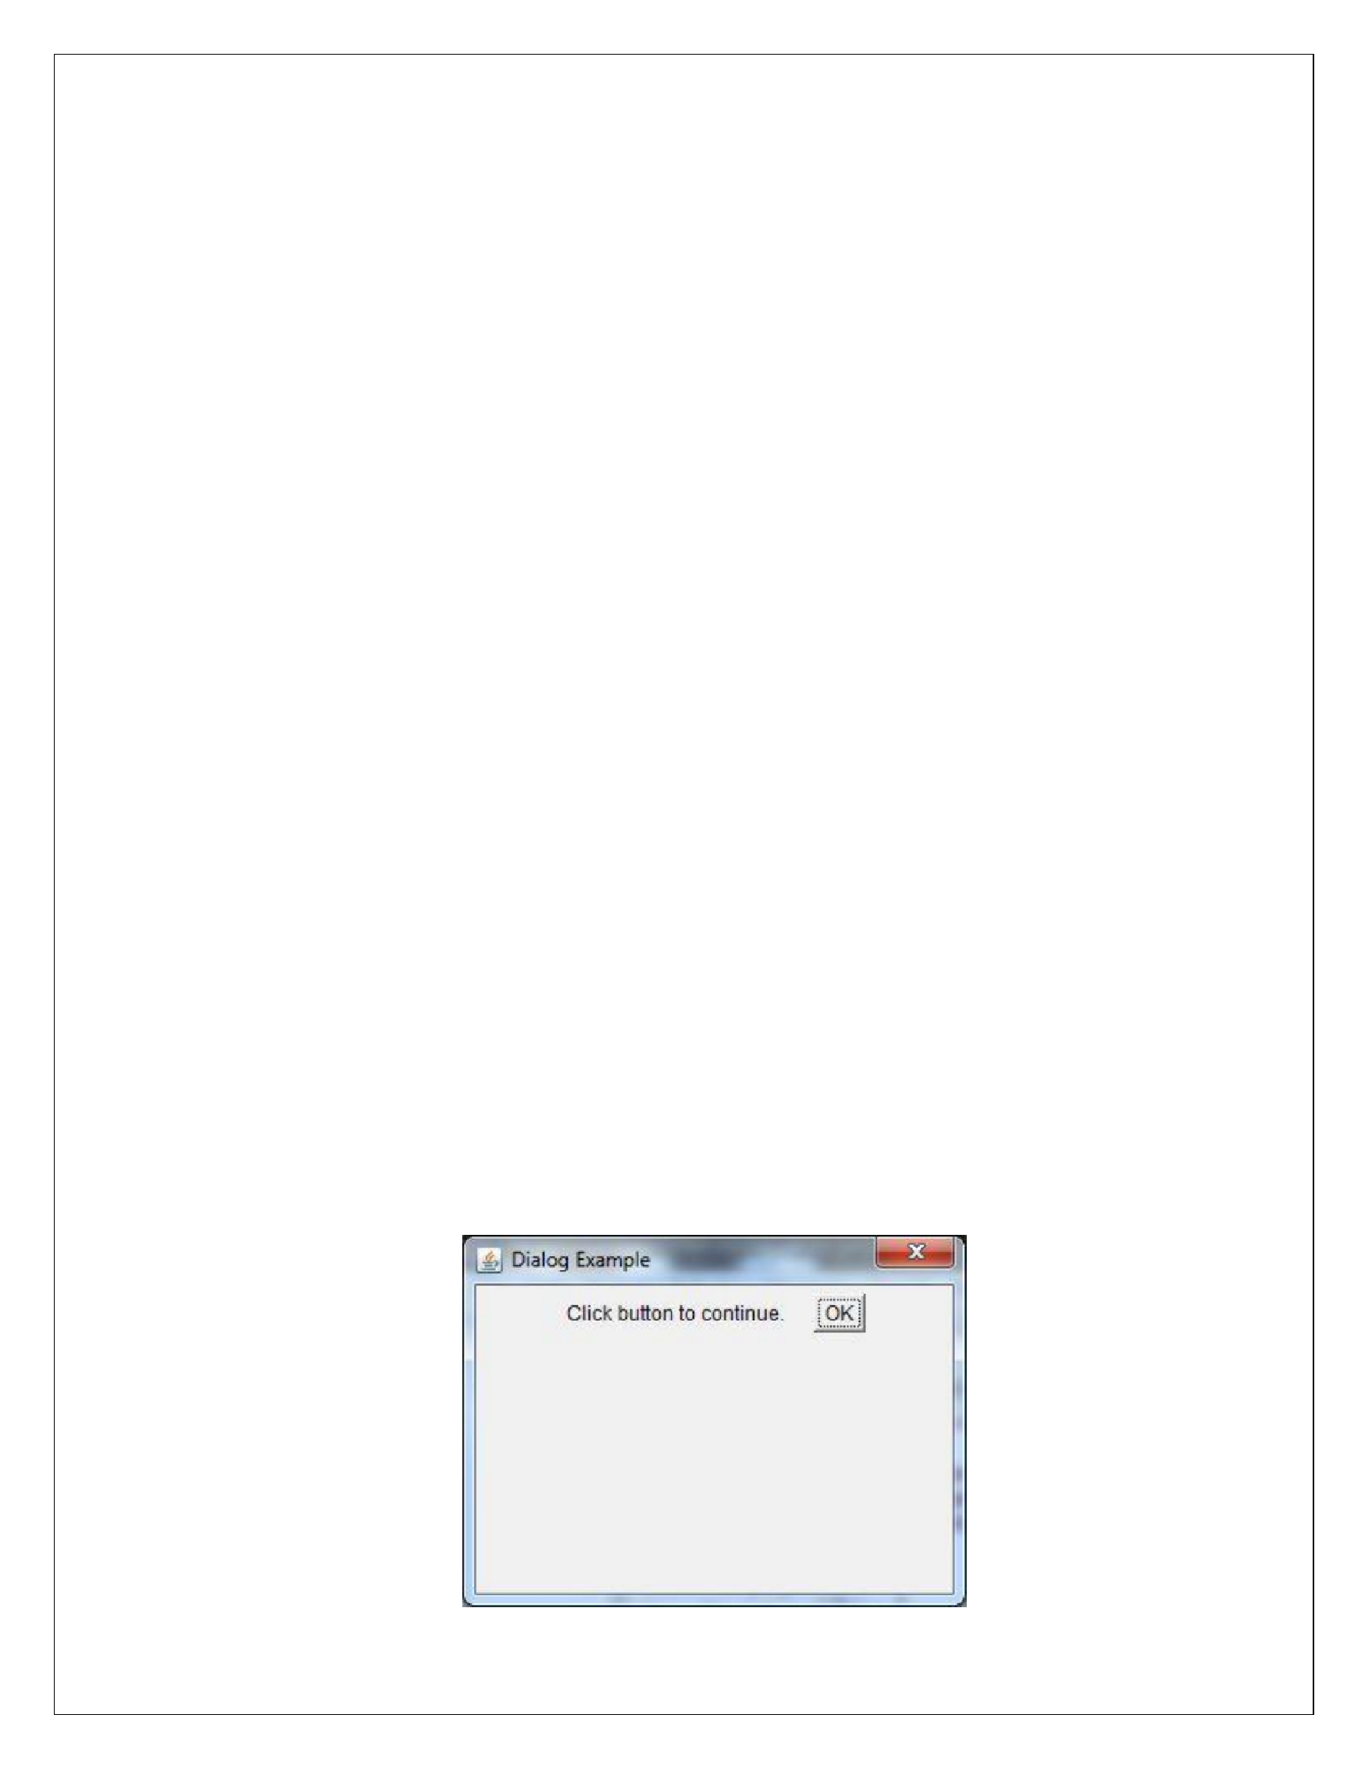
Ja
va A
WT Dialo
g

The
Dialog
control
represe
nts
a
top
l
evel
window
w
ith
a
b
order
and
a
titl
e
used
to
take
som
e
form
of
input from th
e user. I
t i
nherits the Window clas
s.

Example
import java.a
w
t.*;

import java.a
w
t.event.*;

public cl
ass
Dialo
gExampl
e

{
p
rivate sta
tic Dialog

d;
Dialo
gExample()
{

Frame
new Frame();
f=

d = new Dialog(f , "Dialog Example", true);

d.s
etLayout( new F
lowL
ayout()

;
)

Button b = new Button ("OK");

b
.addActio
nListener ( new ActionListener()

{

public void
actionPe
r
formed(
ActionEvent e )

{

Dialog
Example.d.s
etVisible(false);

}

}
;
)

d.a
dd
(
new Label ("Click button

continue."));

to

d.a
dd
(
b);

d.s
etSize(300
,300);

d.s
etVisible(tru
e);
}
p
ublic static void m
ain(String args[])

{

ne
w
DialogE
xample()
;

}
}

Output

www.android.universityupdates.in | www.universityupdates.in | https://telegram.me/jntuh
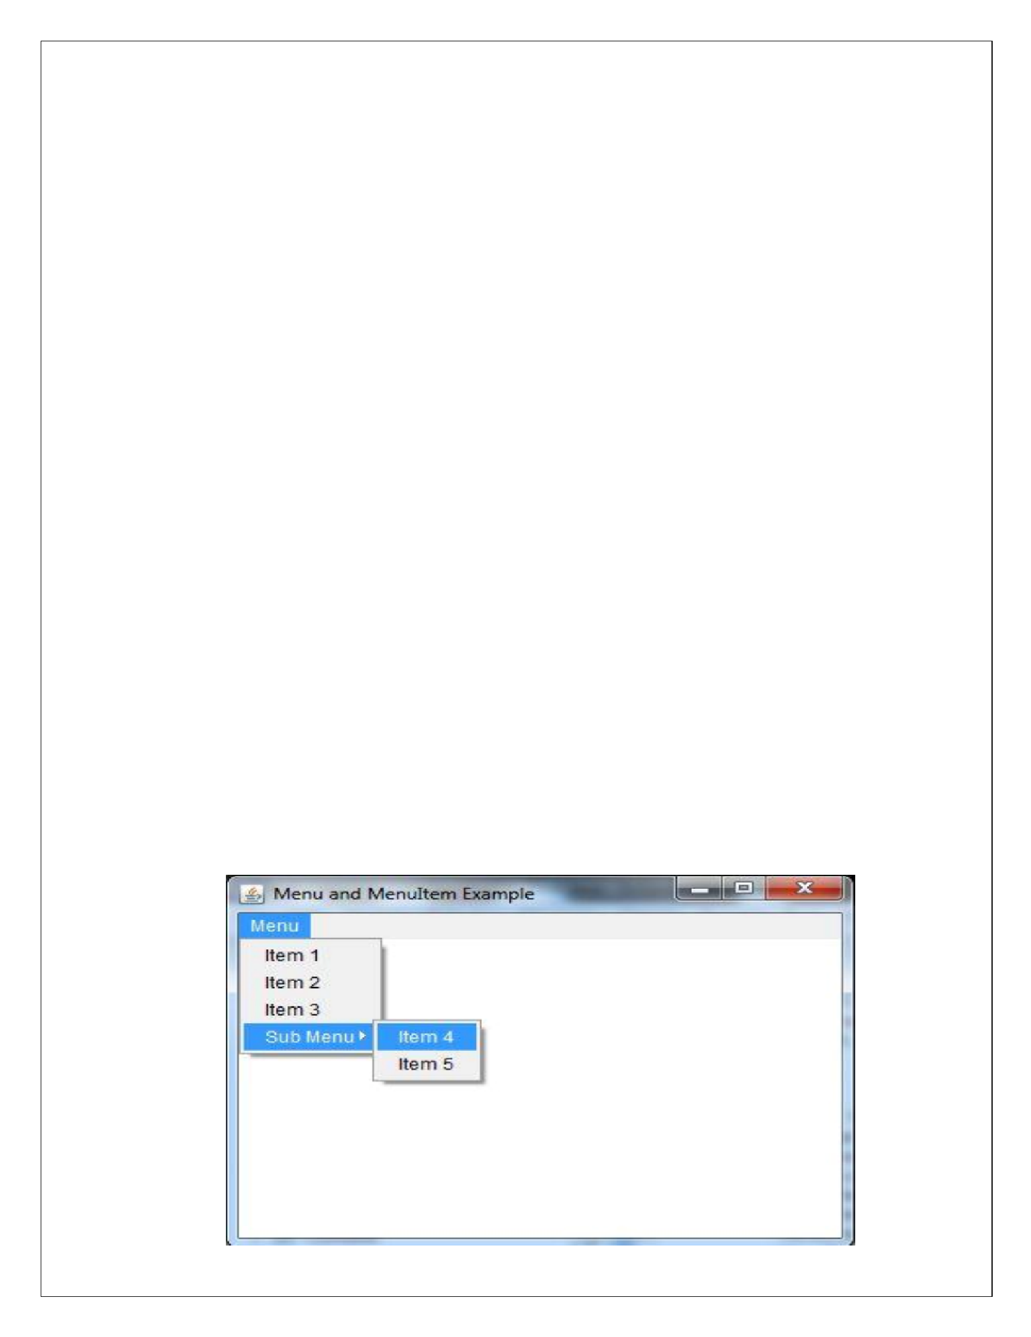
Ja
va A
WT Menubar

import java.a
w
t.*;

class Me
nu
Example
{

MenuExample()
{

Frame
new Frame("Menu
and MenuItem Example");
f=

MenuBar m
b=new MenuBar();

Menu menu=new
Menu("Menu");

Menu submenu=new M
enu("Sub Menu");

MenuItem i1=new M
enuItem("Item 1");

MenuItem i2=new M
enuItem("Item 2");

MenuItem i3=new M
enuItem("Item 3");

MenuItem i4=new M
enuItem("Item 4");

MenuItem i5=new M
enuItem("Item 5");

menu.add(i1);

menu.add(i2);

nu.add(i3);
me

submenu.add(i4);

submenu.add(i5);

menu.add(submenu);

mb.add(menu);

f.se
tM
enuBar(mb);

f.se
tS
ize(400,400
)
;

f.se
tL
ayou
t(null);

f.se
tVi
sible(true);

}
public static void m
ain(String args[])

{

new MenuExample();
}

}

Output

www.android.universityupdates.in | www.universityupdates.in | https://telegram.me/jntuh
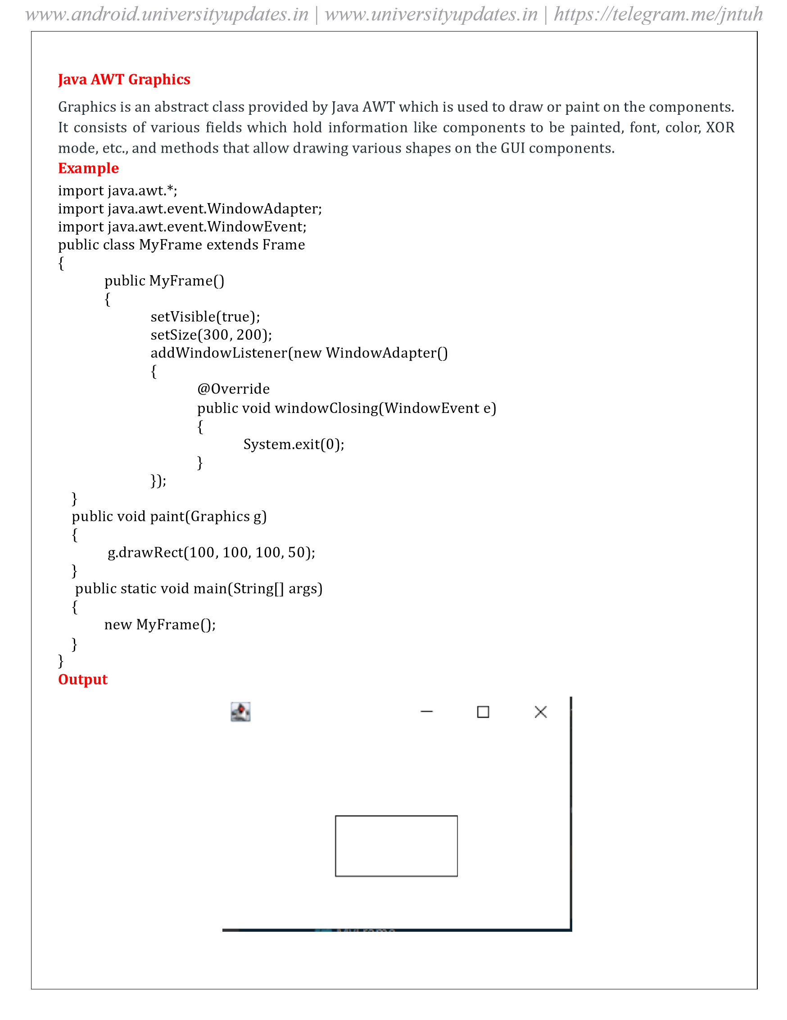
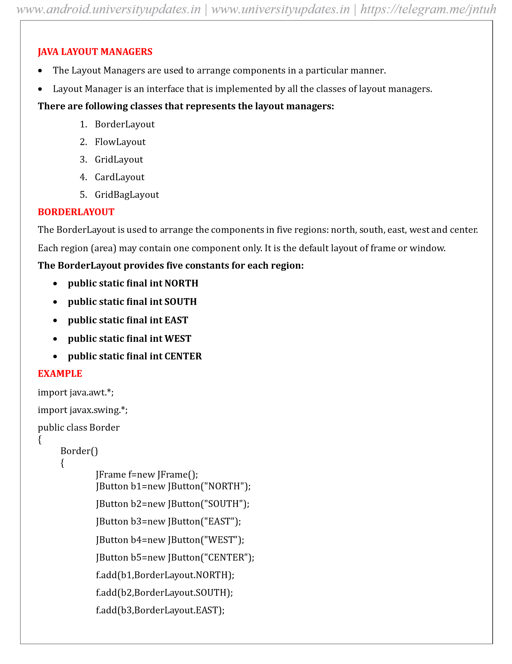
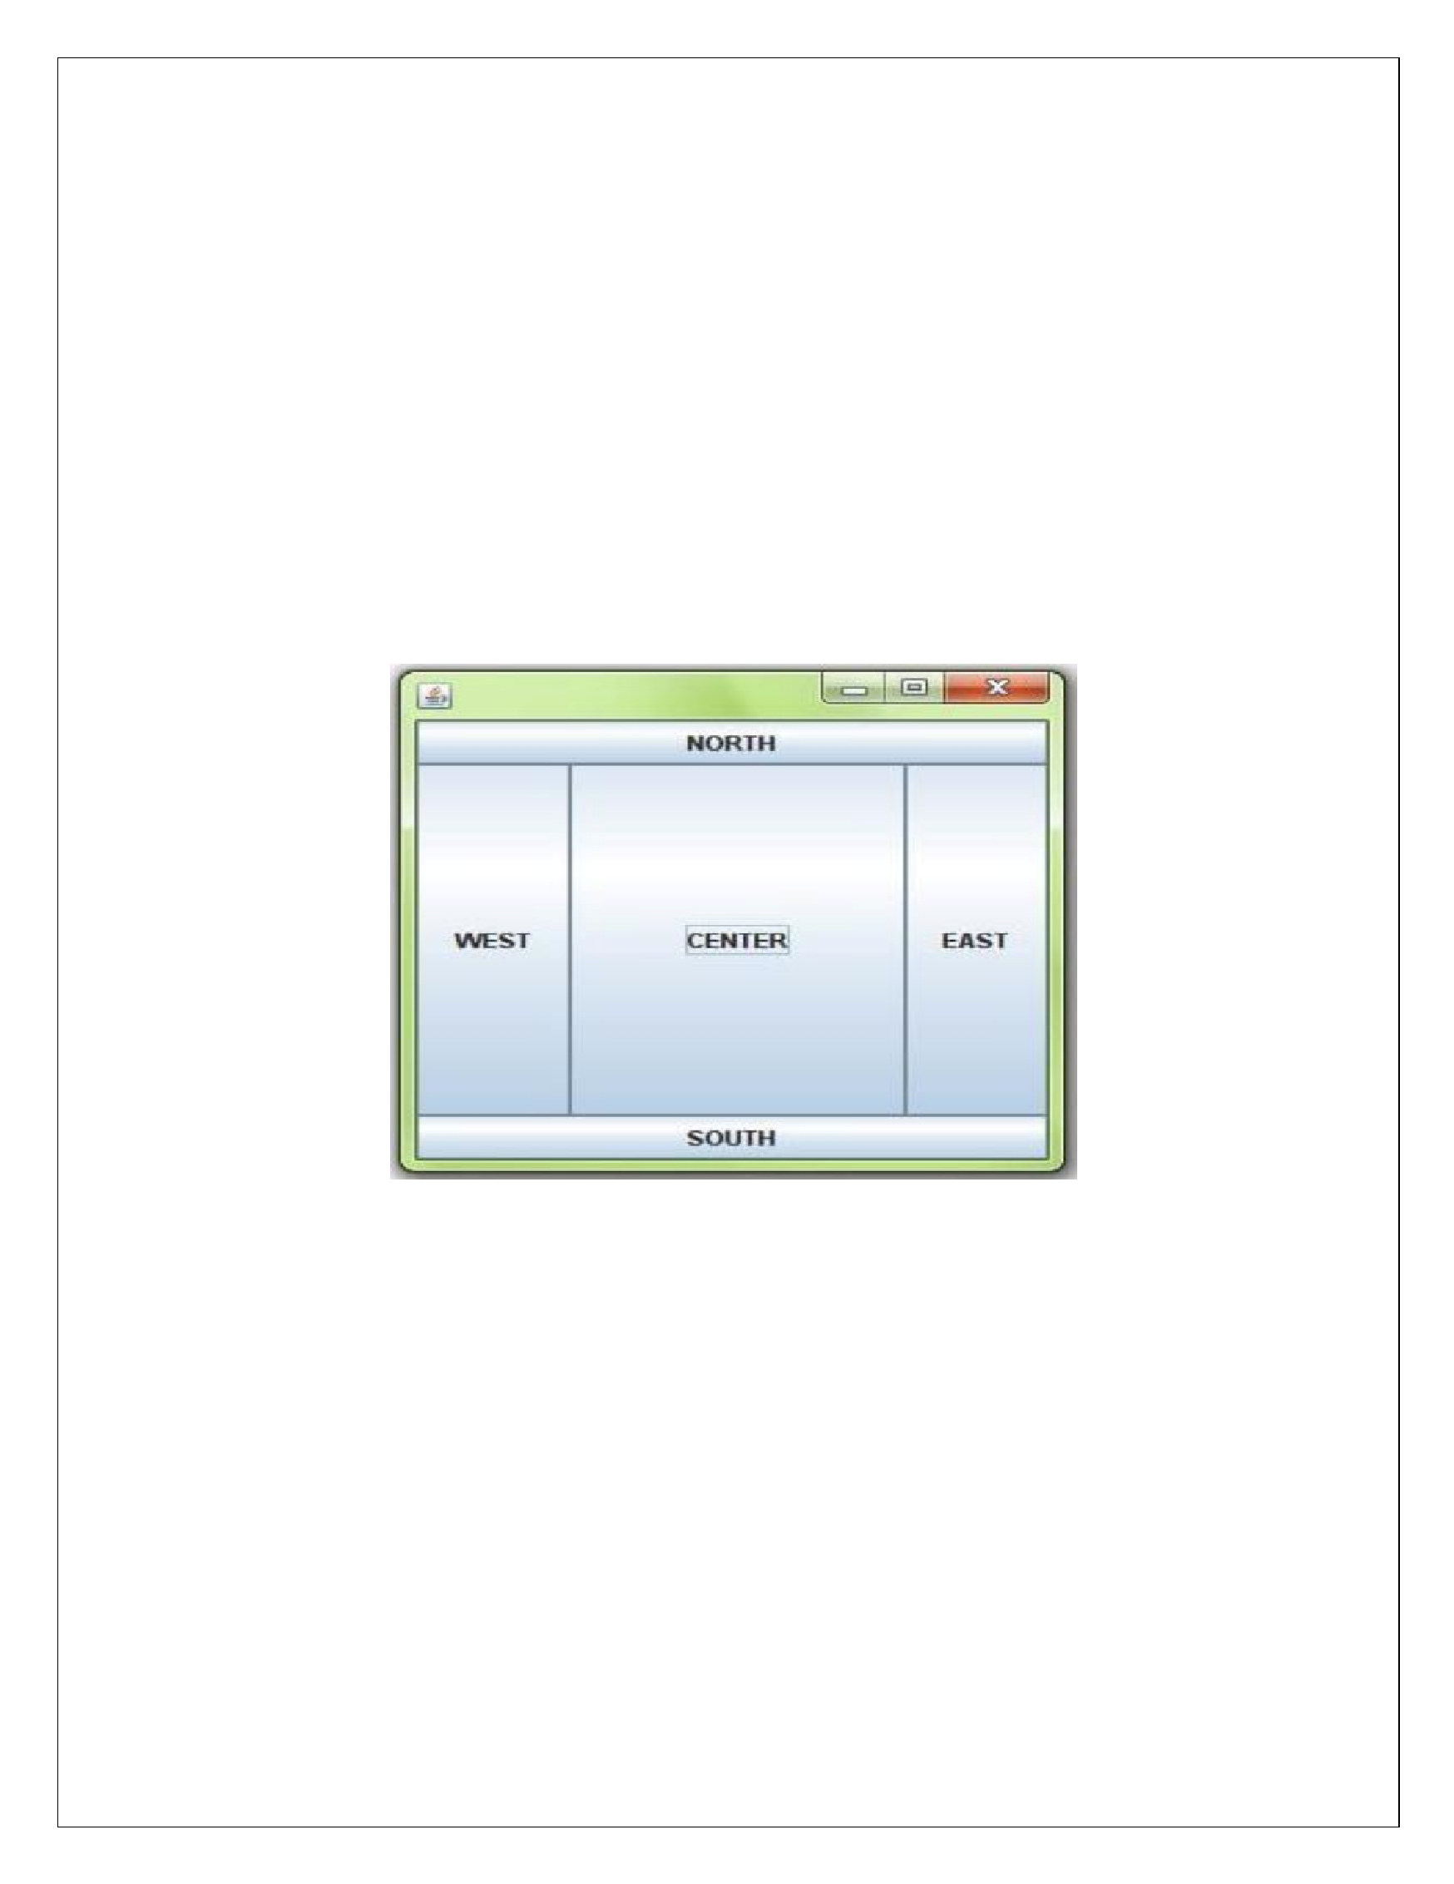

f.add(b4,BorderLa
y
out
.WEST);

f.add(b5,BorderLa
y
out
.CENTER);

f.se
tS
ize(
,
300
300
)
;

f.se
tVi
sible(true
)
;

}

public
static
void
main(String[]
args)

{

new
Border();
}

}

Output:

FLOWLA
Y
OUT

•

This
layout is

u
sed
to
arrange
the
GUI
comp
onents
in
a
se
quential
low
(
that
means
o
ne a
fter
ano
th
er
in
horizontal way)
•

You
can also se
t l
ow layout of components like low from left,
l
ow from right.

Flo
wL
a
yout Left

Fr
ame f=new Fr
ame
()
;

f.se
tL
ay
ou
t(new FlowLay
ou
t(FlowLa
yout.LEFT
))
;

Flo
wL
a
yout Right

Fr
ame f=new Fr
ame
()
;

f.se
tL
ay
ou
t(new FlowLay
ou
t(FlowLa
yout.RIGHT
))

www.android.universityupdates.in | www.universityupdates.in | https://telegram.me/jntuh
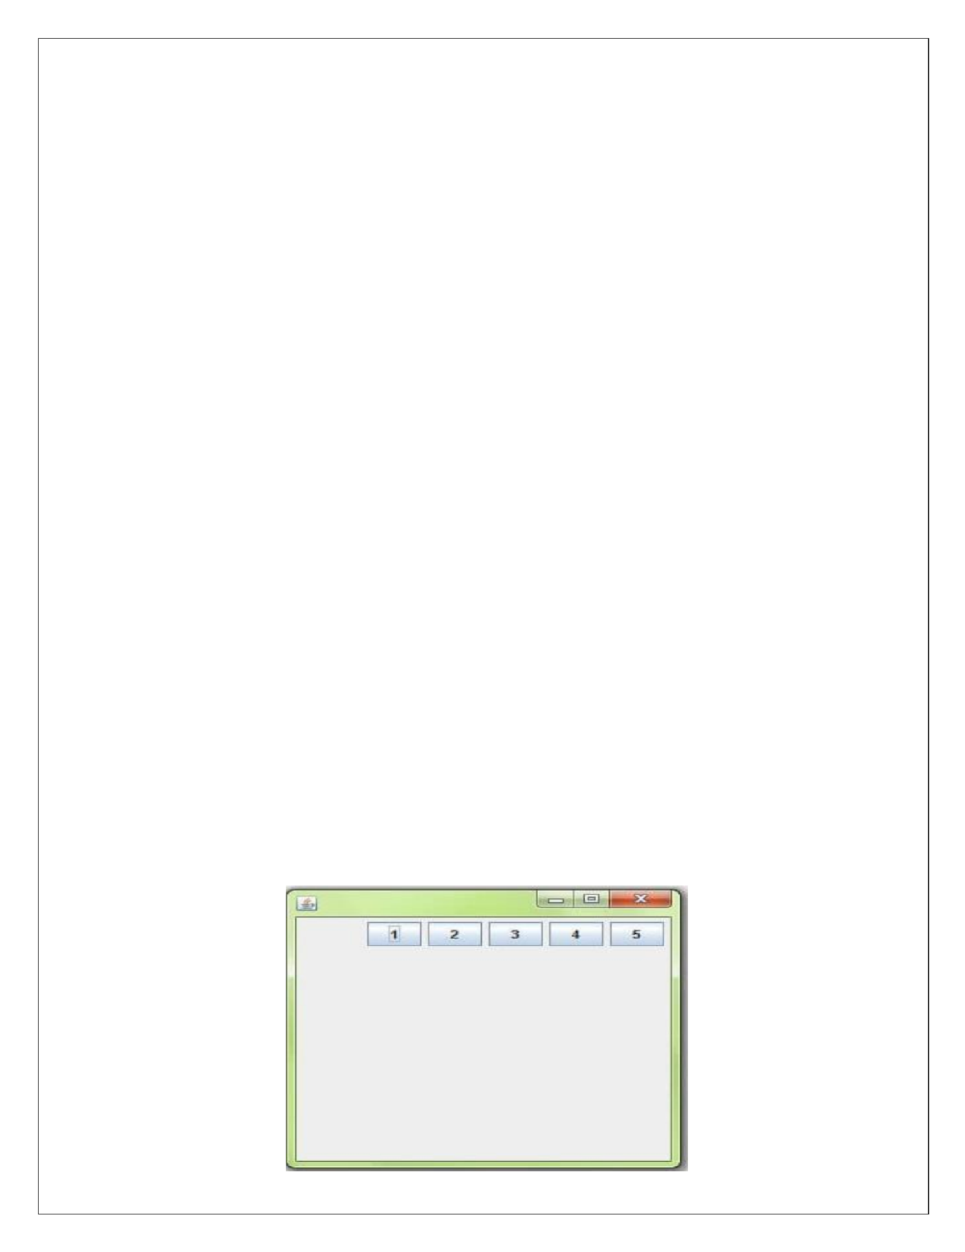
EXAMPLE

import
ja
va.a
w
t
.*;

import
ja
vax.s
win
g.*;

public
cl
ass

M
yFlowLa
yout

{

MyFlowLa
y
o
ut()

{

JF
rame
f=
new

JFr
ame();

JButton
b1=new
JBu
tto
n("
1
"
)
;

JButton
b2=new
JBu
tto
n("
2
"
)
;

JButton
b3=new
JBu
tto
n("
3
"
)
;

JButton
b4=new
JBu
tto
n("
4
"
)
;

JButton
b5=new
JBu
tto
n("
5
"
)
;

f.add(b1);
f.add(b2);

f.add(b3);

f.add(b4);

f.add(b5);

f.se
tL
ay
ou
t(new
Fl
owLa
yout(FlowLa
yout.RIGHT));

f.se
tS
ize(
,
300
300
)
;

f.se
tVi
sible(true
)
;

}

public
static
void
main(String[]
args)

{

new
MyFlowLay
out();

}

}

Output:

www.android.universityupdates.in | www.universityupdates.in | https://telegram.me/jntuh
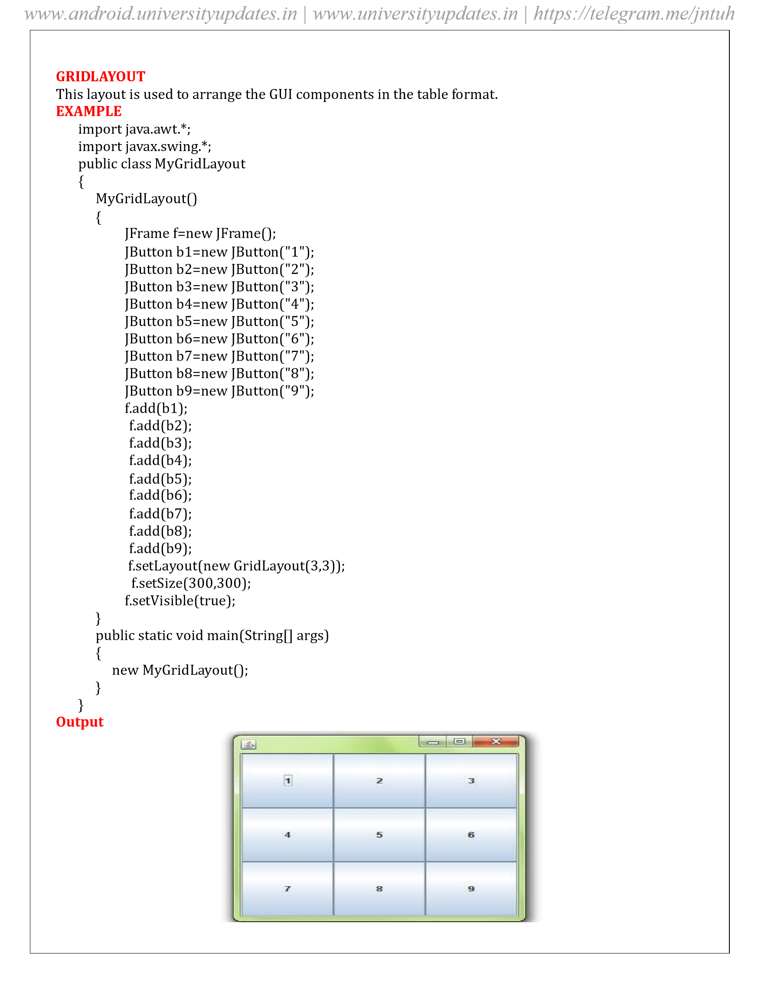
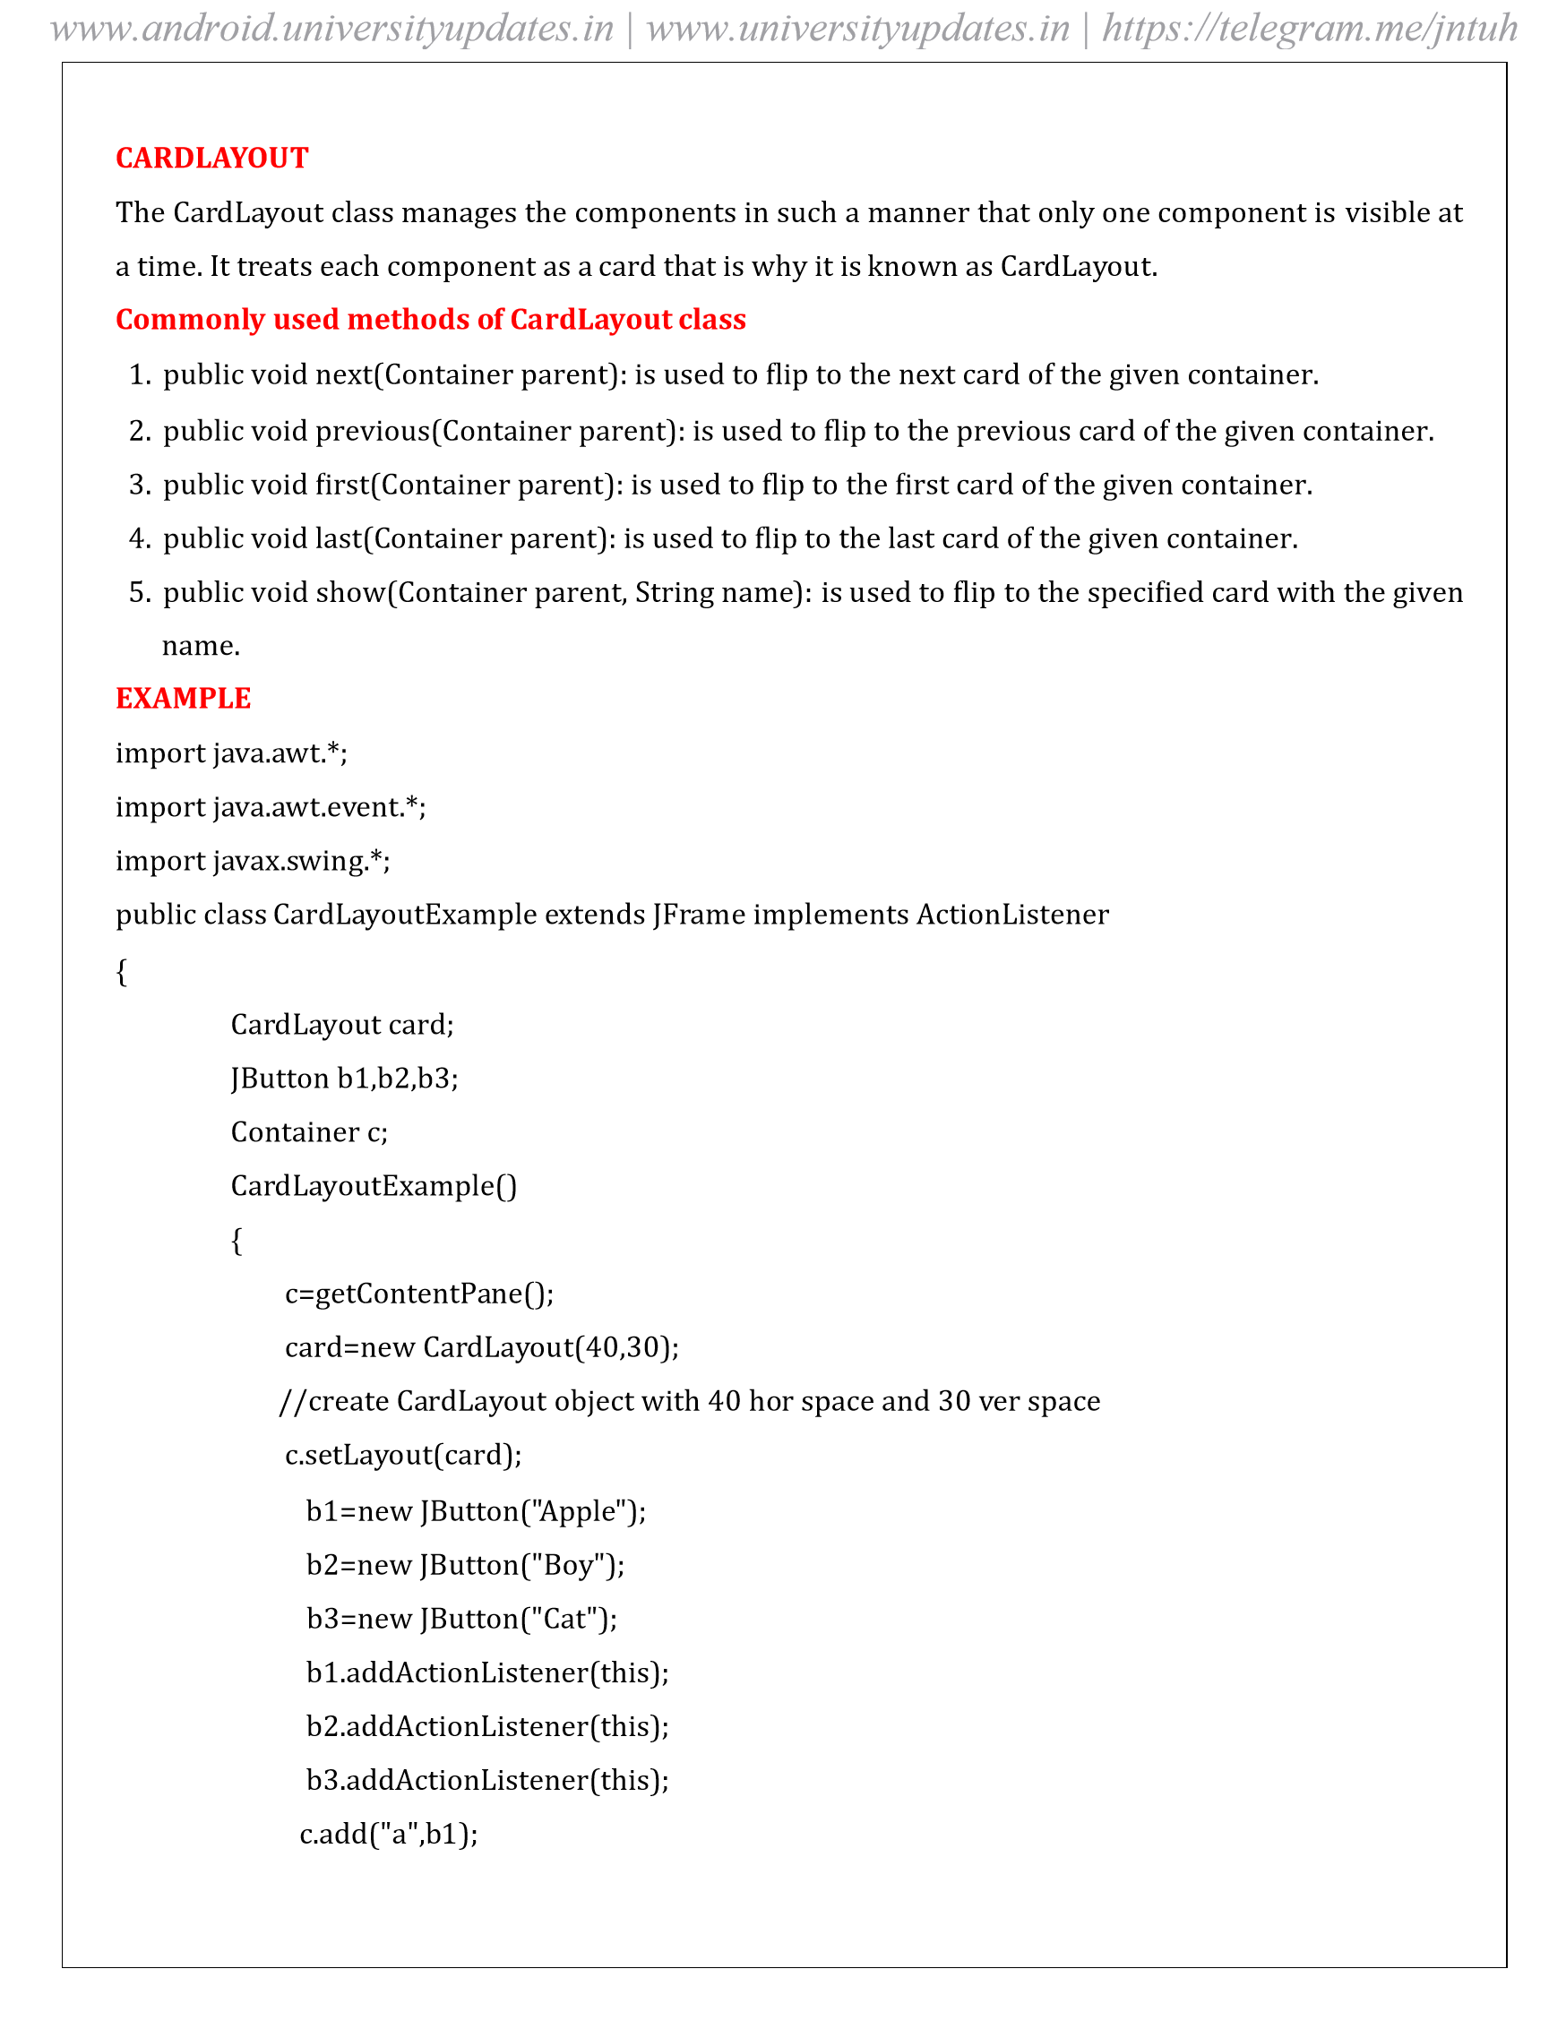
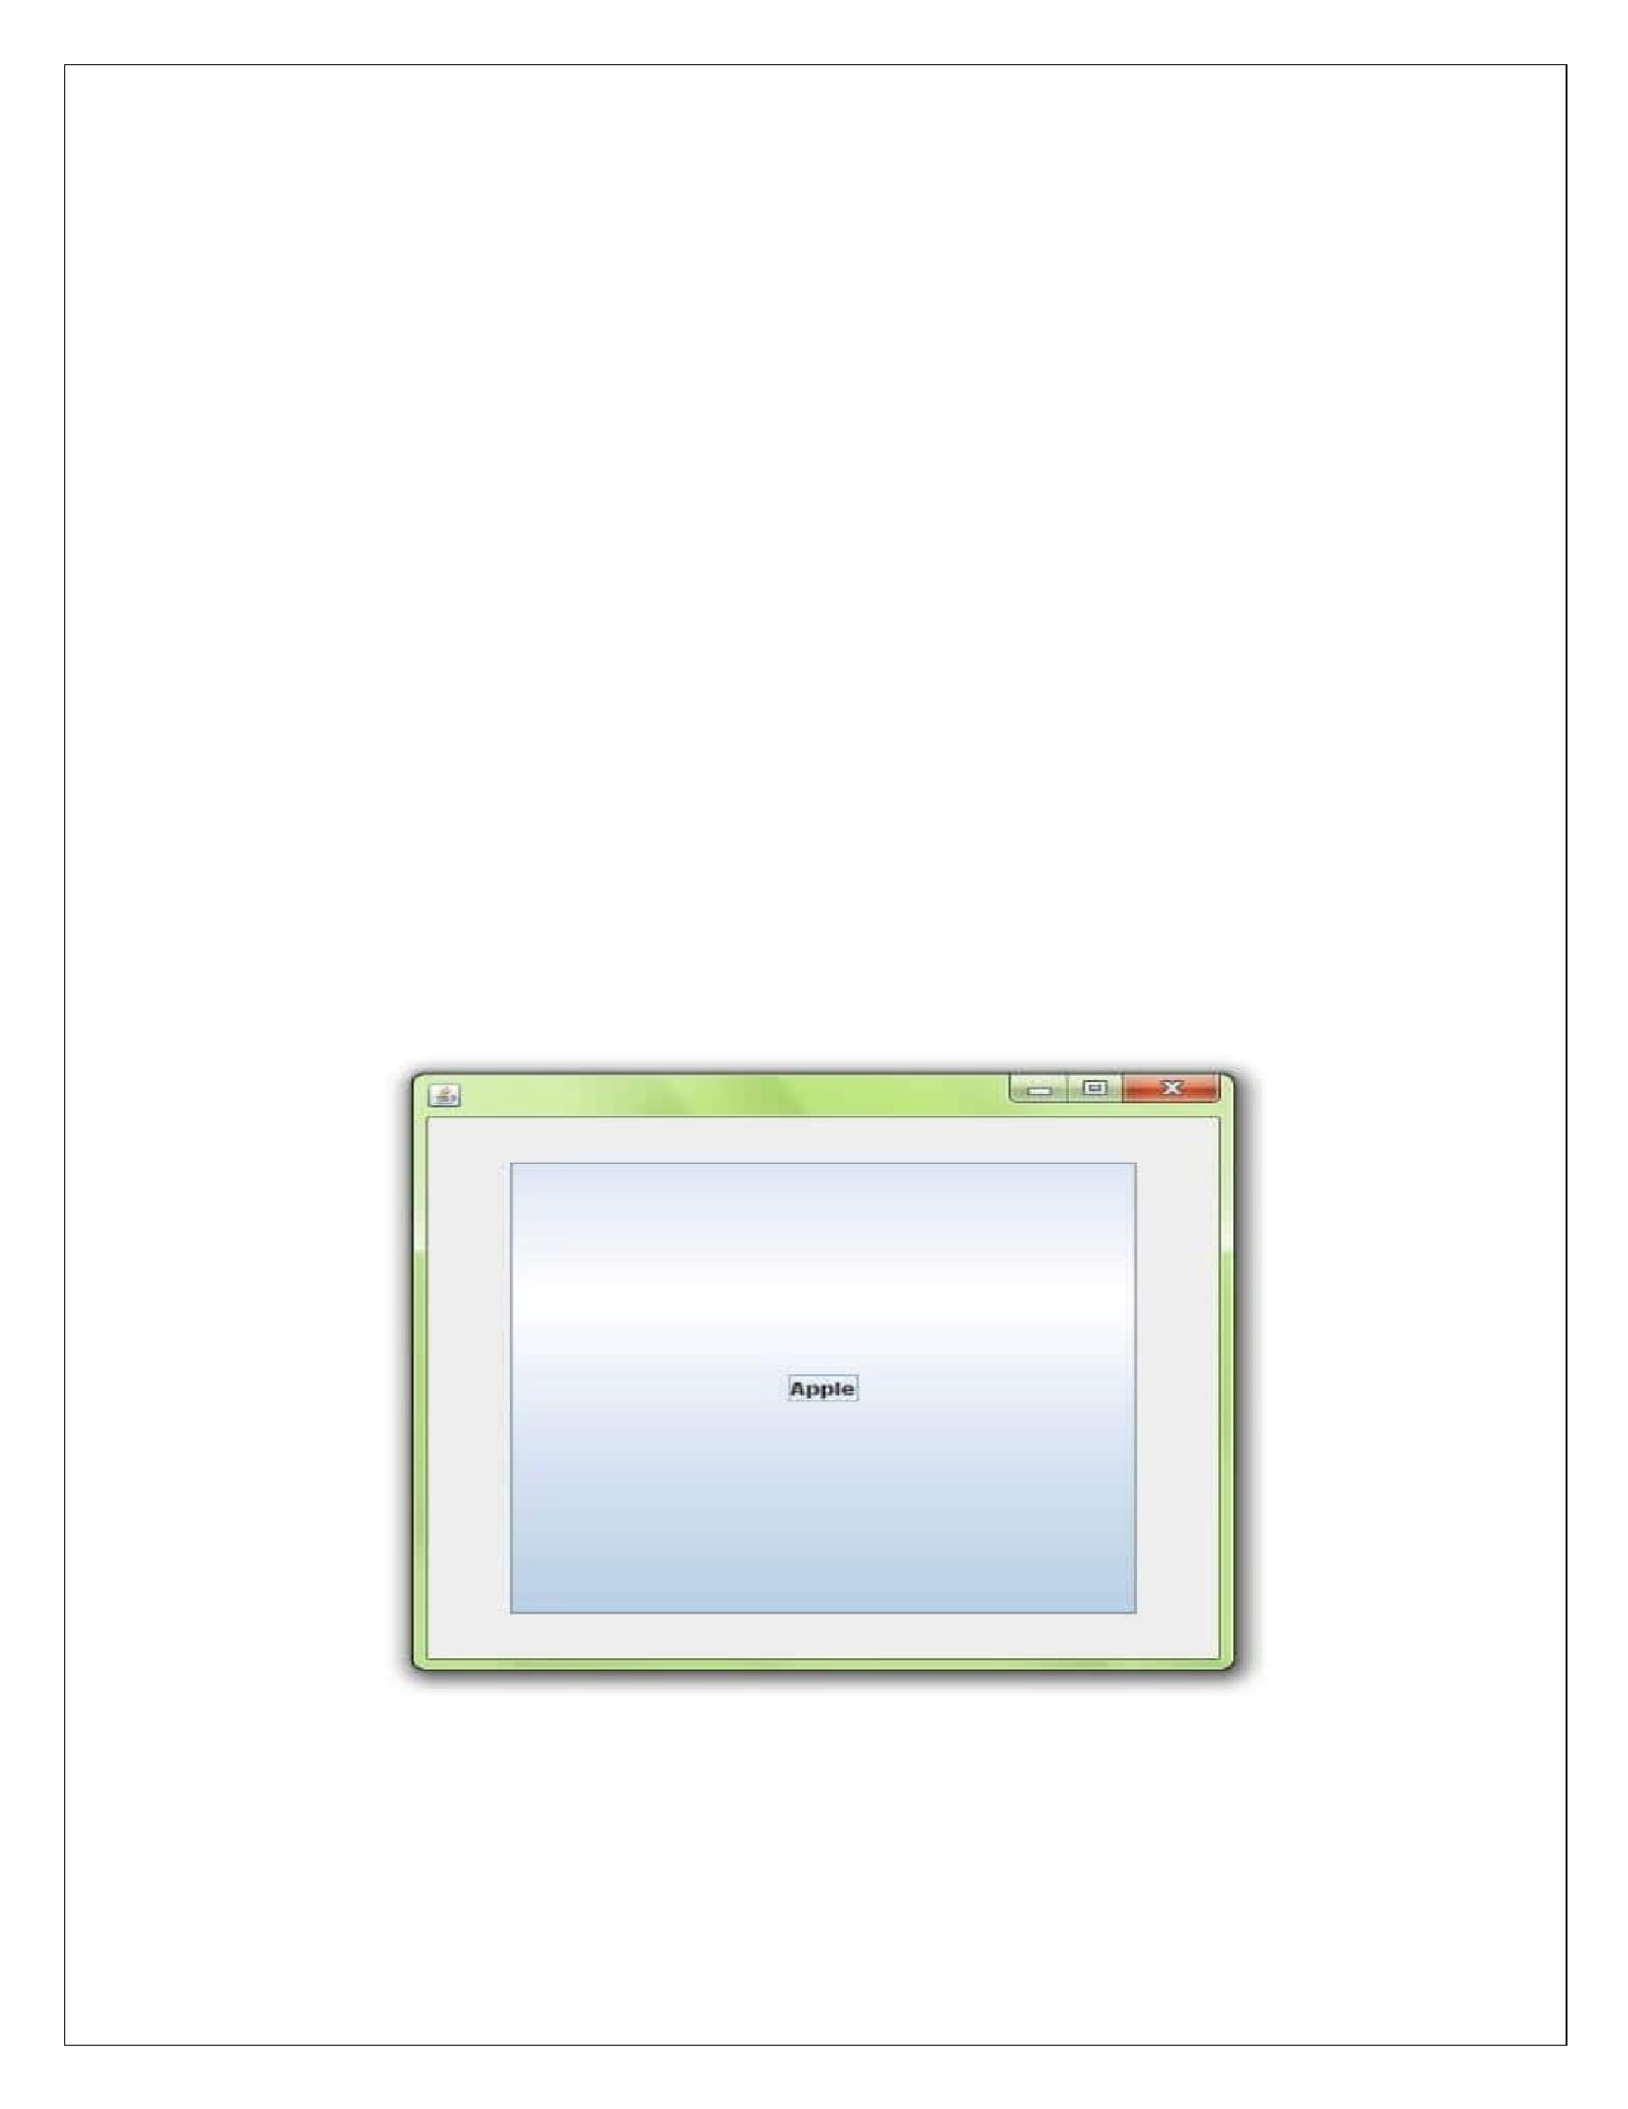
c.add("b
",b2);

c.add("c",b3);

}

public

void

actionPe
rfor
m
ed(ActionE
vent

e)

{

card.
ne
xt(c
)
;

}

public
static
void
main(String[]
args)

{

Car
d
La
youtExample
cl=new
CardLa
youtExample();

cl.setSize(400,400);

cl.setVis
i
ble(tru
e
;
)

cl.setDef
aul
tCloseOpera
ti
on(EX
IT_ON_CLOS
E);

}
}

Output:

www.android.universityupdates.in | www.universityupdates.in | https://telegram.me/jntuh
